|  |
| --- |
|  |
| Lutheran RoseFebruary 2018  CELC Newsletter  **Christ’s Evangelical Lutheran Church**  **Church Website: www.celcstanley.com** |
|  |

**Pastor’s Message:**

**On the necessity of the Holy Church in the life of a Christian**

Grace to you and peace from God our Father and the Lord Jesus Christ.

Every once in a while I’ll run into a fellow or fellowette who sees my tell-tale collar and wants to converse about (but really ‘challenge’) the Bible’s teaching about this or that. Often times it’s about Christ’s Holy Church and this is usually because they’ve had a bad experience or someone was not “Christian” to them. I get questions like:

**Why do you believe it’s necessary for Christians to attend church?  Don’t you think I can be just as good a Christian without going to church? I have a personal relationship with God what do I need church for?**

First, plainly stated-- No, you can’t be just as good a Christian without going to church.  But first we’ve got to agree on what we’re talking about when we say “church”. When we say “church” we can mean a denomination, a parish, a building or an institution. However, not one of these describes how the Bible explains the Church. In the Old Testament “church” is *qahal* *Yahweh*, Hebrew for “the assembly of the Lord.”  In the New Testament, “church” is *ekklesia*, Greek for “an assembly of believers.” The Latin translation of ekklesia or qahal would be *congregatio.*

The purpose of this assembling or congregating is to worship God, to hear God’s Word, to pray for the world, to receive the Sacraments instituted by Christ, and organize for mission.  When we worship on Sunday morning we proclaim God’s Name before and to the world. Therefore, worship is *always* public.  In the Word read and preached, we hear God’s will and promise for us and for the world. Moreover, when we assemble in the Name of our God for the sake of praying for the world we embody our priestly role given at Baptism of interceding on behalf of the world (1Pet.2.9).

In the Sacraments we are brought into communion with God and also with one another in the Body of Christ.  In coming together for mission we prayerfully discern (with the promised guidance of the Holy Spirit) how to best proceed with the work of the Gospel.

The whole history of salvation is the story of God calling, gathering, illuminating, and making holy a people to be his own possession—from our fathers the Patriarchs, from whom God biologically births the people of Israel, through the ingathering of the saints into the Kingdom of the Lamb in the Book of Revelation.

Yes, individuals are called by God to special service.  But that service always entails a task related to the assembled people of God, whether it be Abraham becoming the father of a nation or Moses delivering that nation from its bondage under pharaoh and then receiving God’s Law or the prophets being given the Word of the Lord to deliver to the assembly, or Paul taking the Gospel of the crucified and risen Jesus to the Gentiles.

As individuals, we are sent out *from the assembly* to witness to what God has done and is doing through his Son Jesus the Messiah. And, yes, Christians should most certainly also be connected with God apart from the assembly, in their own daily prayer lives and that of their families—something that has largely fallen by the wayside in our increasingly busy lives. But the prayer our Lord has taught us to pray is still “*Our* Father”.

The Christian does not exist alone by him or herself. Nowhere in the Bible will you see ever see a “Me and Jesus” mentality lifted up to the exclusion of the rest of the Body. One becomes a Christian by being baptized (Titus 3.4-6; 1Pet 3.21; et al).  Baptism brings the person into the community of God that is called the Body of Christ. Therefore, Baptism is not at all some sort of contrived understanding that you have between yourself and God, it’s the chief means of God’s grace to his Church; his holy assembly.  The life of faith is learned in this community.  There’s no way to be a Christian apart from the Church.  Which means it’s good to check in with the assembly once in a while—maybe once or twice a week!

Let us serve the Lord together in the ways he enabled us to. +Pastor

ASSISTING MINISTER INSTRUCTION

February 13th 6:00 PM

Christ’s Nave.

Calling all new and current Assisting Ministers!

The Pastor will be having instruction on the duties of serving the Altar in this capacity. Please try to be present so we can tighten up and streamline some of our current practices.

There will be time for questions and answers so be prepared to ask away! There will also be time for our new assistants to enter into the Sanctuary (area around the Altar) so they can get a feel for what it’s like.

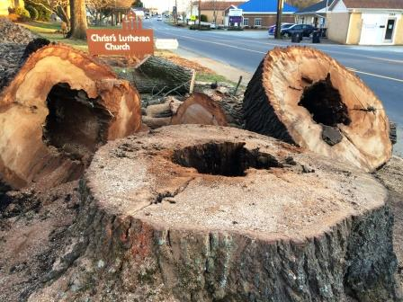

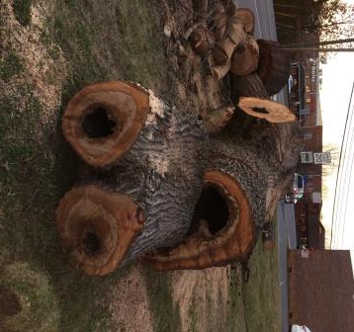

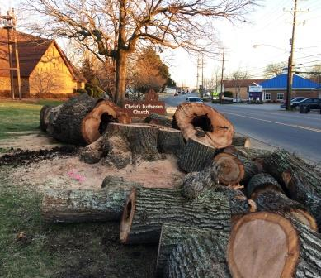

“A Holy Tree on Holy Ground”  
           On January 29th one of our beautiful old oak trees at the edge of Hwy. 27 was taken down for safety purposes after an arborist examined the tree and made this recommendation. As you can see from these pictures much of the tree was hollow.

Prayer Concerns

|  |  |
| --- | --- |
| Immediate Care Concerns: | Bertie Billups,Tyree Bost, Richard Smith, Susan Wyatt, Eddie Wyatt, Lindy Hawley, Christine Wallace, Gaynelle Moore, Lenore Lay, Pearl Summey, Libby Michael, Jimmy Harrison |
| Home-bound Members: | Ruth Cloninger, Gaynelle Moore, Phyllis Hawley, Pearl Summey, Lindy Hawley |
| Members in Nursing Homes: | Lenore Lay, Edna Lineberger (502 B), are in Stanley Total Living Center, Christine Wallace is at Huntersville Health & Rehabilitation  Center, 13835 Boren St. Huntersville, Sarah Lewis is at Carillon Cramer Mountain (Room C-6). |

Friends and Relatives:

Everette Lineberger Jewel West Cindy Turry Bob Stewart Chris Davidson

Ann Lineberger Eddie Rhyne Jennifer Champange Betty Jones Harry Murphy

Karen Scrivani Joe Canipe Tom Hodge Steve McAlister Eleanor Flowers

Ron Ritchie Tom Olls Wanda Murphy Amy Blythe Robert Caskaddon

Bob Hilton Rod Rudisill Vivian Lineberger

|  |  |
| --- | --- |
| **January’s Attendance** | |
| Jan. 7 | 65 |
| Jan. 14 | 82 |
| Jan. 21 | 82 |
| Jan. 28 | 77 |
| **Average** | **77** |

February Birthday’s

19 Lenore Lay

19 Emma Powell

26 Ann Harrison

27 Ruth Ridge

27 Susan Wyatt

27 Sally Mahovsky

1 Danielle Clippard

2 Ron Abernathy

5 Janice Clark

5 Michael Olls

5 Rebekah Olls

6 Libby Michael

Anniversary

15 Leonard & Loretta Lewis

Baptism Anniversary

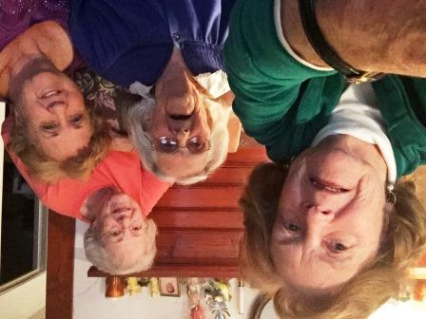

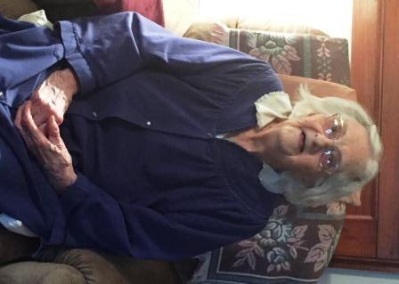

Birthday wishes were delivered to Ms. Pearl Summey on her 98th!

Three visitors enjoyed the conversion and especially the stories about the good old days told by Ms.Pearl.

A treasure to behold and cherish is this lady who has supplied many a church meeting with her home grown flowers.

2 Amelia Clark

2 Whitney Clark

2 Ruth Cloninger

2 Ansley Spears

10 Wesley Clark

12 Neal Ritchie

12 Brian Robinson

16 Kelli Costner

24 Ann Lineberger

24 Richard Smith

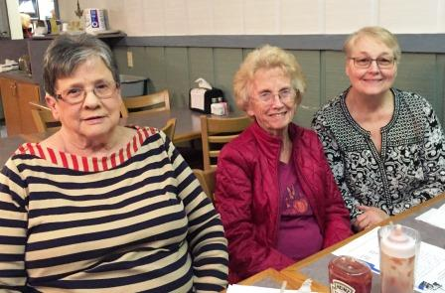

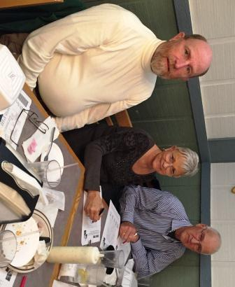

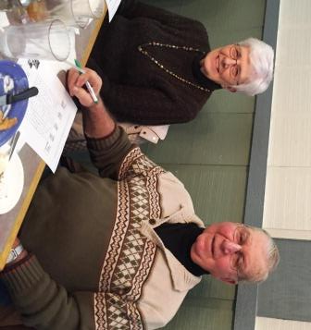

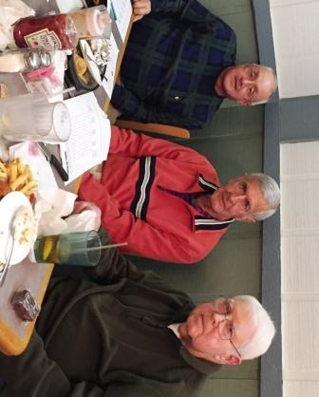

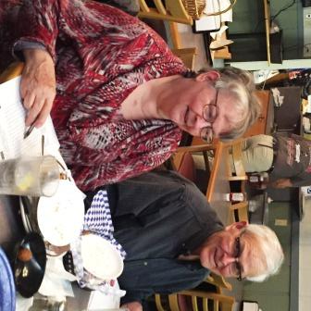

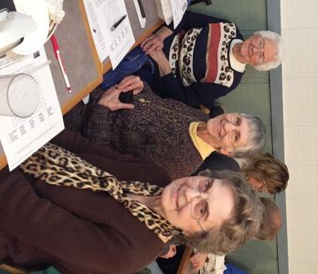

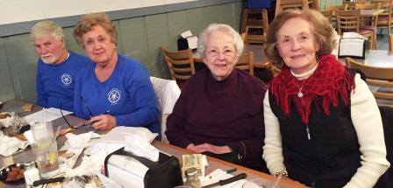

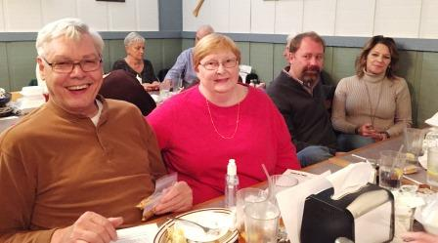

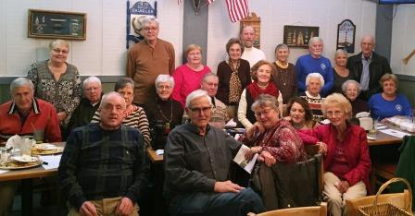

What a crowd!  We had 24 Lutherans that enjoyed fish and all the trimmings Saturday night at Captain's Cap!

Great fellowship, fun and games.  Pie and cookies for dessert put the finishing touches on a wonderful night spend together.

**A Note from the Church Council President**

**Gifts**

**This year Ash Wednesday is on Valentine’s Day. As we begin our Lenten journey many of us think about what we are going to “give up” for the Lent. Some of us think about what we can give.**

**What comes to mind when we think about gifts? Is it a nicely wrapped present? Is the gift something that is expected and done out of obligation or is it a choice out of our desire to do something thoughtful, generous, unexpected and kind? Many of us think of giving gifts for Valentine’s Day, Christmas, birthdays, and other occasions.**

**Consider the gifts that people give on a daily basis that cannot be wrapped or placed in a gift bag. Intangible gifts, invisible gifts, spiritual and unbreakable. More valuable than diamonds. It can be big or small. It’s appreciated. The gift of love that blesses our relationships. The gift of laughter when there are plenty of reasons to cry. The gift of patience in an impatient world. The gift of time. The gift of listening or the gift of silence. The gift of hope. The gift of serving one another. The gift of generosity. The gift of faithfulness. The gift of kindness. These are the gifts that last a lifetime. These are gifts that will bless us and the world around us. May we and all of those around us blessed with the best gift exchange we can ever imagine this day...this week...this month...this year in this lifetime we’ve been given.**

**Blessing to All,**

**Judy Abernathy**

**Council President**

**Safety and Security at CELC**

On November 21, 2017 a Security Assessment of CELC was conducted by Officer Matt Johnson of the Gaston County Police Department, in an effort to lay the groundwork for a safety preparedness plan for our church.

Officer Johnson with Jay Human did a walk-through property assessment of the church, educational building and family life center and parking areas.

At the January 14, 2018 meeting, Council recommenced a Safety/Security team be established, and initial recommendations be implemented. The following were appointed to the Safety/Security Team: Bud Abernathy, Gil Harris, Jay Human, Leonard Lewis, Richard Medlin, Brian Robinson, and Tonya Stone.

ACCESS CONTROL was the top recommendation in the safety and security assessment that was conducted.

Effective Sunday, February 4, 2018 entrance to the Church Nave Sanctuary will be limited to the FRONT DOOR and the SIDE DOOR at the covered walkway entering memorial corridor. All other doors will be locked and should not be accessed. (Note-In case of an emergency ALL DOORS can be exited)

Access to the Educational Building will be limited to the side covered porch entrance. All other doors will be locked.

Council understands limiting access may be an inconvenience however the safety and security of our church and congregation outweighs convenience. Thank you for your support and cooperation.

**Michael & Judy Bozeman joined our church family on Nov. 4, 2017.**

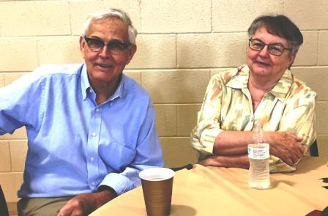**Michael was born in Lumberton NC and moved to Long Island NY at age 7 and then later moved back to Charlotte NC at the age of 16. Mike graduated East Mecklenburg High School and attended CPCC. He retired from Duke Power on March 1, 2006 after being a lineman for 32 years. Since retiring he has been an electrician for contractors and does handcrafting leather products for Colson Kean Leather. His interests are leather working, guns, target shooting, woodcarving, knife collecting and bread baking. He has volunteered at Via de Cristo, Kairos Prison Ministry, done numerous activities at former Churches, Commonwealth Baptist Church, Mulberry Baptist, and A Mighty fortress Lutheran Church in Charlotte NC.**

**Judy was born in Mt. Airy, NC (Mayberry). She attended Guilford College in Greensboro and then graduated Winthrop College in Rock Hill with a BA Psychology. She also has an AA from Gaston College. Judy has had various office jobs and has worked at DSS-Gaston Co., Social Worker in Protective Services and did Medical Social Work at Emerald Health Care & Gaston Memorial Home Health. Her interests are theater, health/nutrition, cooking, crochet, crafts reading and Zumba. She has volunteered as an usher for 10 years at Blumenthal Performing Arts Center, Theater Charlotte, CPCC and Actors Theater. She has also done various activities at mulberry Baptist church in Charlotte and A Mighty Fortress Lutheran Church in Charlotte. Judy has been a Brownie Scout Leader.**

**Mike & Judy married on July 3, 1982 and have a daughter Amanda Bozeman Williams. Judy has a daughter and son-in-law from a previous marriage named Heather Guy. Heather and her husband Glen have a 14 year old daughter named Goldie.**

**Mike & Judy wish to thank Christ Lutheran members for the warm welcoming to the church. We feel blessed to have been led to your church family.**

**God’s Peace,**

**Mike & Judy Bozeman**

**Annual Report**

We will be issuing an Annual Report for 2017 in March. Please if you have any corrections on your address, phone number, or email address let Julie know.

**A SPECIAL REQUEST FOR YOUR SUPPORT:**

 As you may have heard CELC will be making a presentation before the Town of Stanley Council on **Monday, February 5,** 2018, at **6:00 p.m.**concerning the financial maintenance responsibility of the cemetery grounds. That meeting will be held **in the gymnasium in Harper Park**.  Please make arrangements to attend that meeting to show support for our church’s position on this important issue.

**United in Action of Stanley Churches, Inc. 2018**

**Noon Day Lenten Season Service**

* ASH Wednesday Noon Day Service, Wednesday, February 14, 2018, 12:00 noon Christ's Evangelical Lutheran Church, 203 South Main Street, Stanley, N.C. 28164 Reverend Wesley R. Frye, Host Pastor Guest Evangelist: Reverend Ronnie Roseboro, Pastor, Ebenezer United Methodist Church, 120 Belmont-Mt. Holly Road, Belmont, N.C. 28012

* Noon Day Lenten Service, Wednesday, February 21, 2018, 12:00 noon COMMONGROUND Campus, First United Methodist Church, 5481 Hickory Grove Road, Stanley, N.C. 28164, Pastor Noel Sweezy, Host Pastor Guest Evangelist, Pastor Michael Crisp, Co-Pastor, ONE CHURCH, 1809 Hickory Grove Road, Gastonia, N.C. 28056

* Noon Day Lenten Service, Wednesday, February 28, 2018, 12:00 noon, New Life Baptist Church, 527 North Buckoak Street, Stanley, N.C. 28164 Pastor David McClure, Host Pastor Guest Evangelist: Dr. Kendall Cameron, Senior Pastor, First Baptist Church, 300 S. Main Street, Mt. Holly, N.C. 28120



**Lenten Services at Christ’s Lutheran**

We are starting the season with Ash Wednesday Evening service at 7pm. The Lenten Services will begin with a meal at 5:45-6:30pm and the Service will be at 7pm on Feb. 21, Feb. 28, March 7, March 14, March 21. Please plan to attend for a wonderful time of fellowship.

**Save the Date**

**Toilet Paper Drive**

The Women of the Church are starting a toilet paper drive for the food pantry. Please bring toilet paper and put on the table in the memorial corridor. Thanks

**Women’s Bible Study**

The next Women’s Bible Study will be on February 13th at 10pm in the Fellowship Hall. Please remember to bring toilet paper.

**Help us celebrate “Valentine’s Day” For Others**

Showing our Love and Care for the members of CELC!

There is a “Valentine” Box in the back of the church just for your cards.

NO address needed …only the name on the front of the envelope and yours inside.

Ideas would be for our shut-ins, sick or just anyone who could use a friendly reminder that they are thought about this special day!

There are cupid’s who will deliver the cards for you.

The final day accepting cards will be Sunday, February 11, 2018! Any card will do … homemade, kids type cards or the single purchased type.

Remember it’s the thought that counts!

Questions…just ask one of the Prime Timers! Enjoy the fun!!!

**Congregational Meeting**

A congregational meeting will be held immediately following worship service on Sunday, February 4, 2018 for the purpose of discussing and approving removal and replacement of the Family Life Center flooring.  Everyone is encouraged to attend.

Thank you,

Judy Abernathy

Church Council President

**Advent Lutheran Church Cordially invites you to a**

**Ground Breaking Ceremony For the NALC Disaster Relief Warehouse**

**Feb. 11th at 4pm**

**230 Oak Grove Rd, Kings Mt. NC 28086**

**Service will take place outside, please dress accordingly.**

**Reception to follow,**

**Please RSVP pastor@adventkm.org**

**CHURCH COUNCIL MEETING**

**November 12, 2017**

**MINUTES** **OF** **MEETING**

**Devotions:**  Prissy Helms opened the meeting with a devotional reading and prayer.

**Roll call and action on excuses for absence**:

**Present:** Pastor Frye, Judy Abernathy, Bud Abernathy, Judy Ray, Tommy Hedrick, Prissy Helms, Crystyl Human, Emma Human, David Lewis, Michael Dukes, Pat McAlister, Nancy Olls, Laura Olls (Youth), Tonya Stone, Leonard Lewis, Richard Medlin, Joe Keefer

**Absent:** Janie Beard, Brian Robinson

**Minutes of last meeting:**  The minutes of the October 8, 2017 Council meeting were approved, with corrections.

**Reception of petitions and communications and new business:**

1. We welcomed our new Council members. They are Richard Medlin, Leonard Lewis, Nancy Olls, and Crystyl Human. Also, a big welcome to Laura Olls, our new Council Youth representative.
2. Judy noted that the budget for 2018 was approved unanimously by the congregation at the annual congregational meeting.
3. A note about our lawn care service. Sparky’s (owned by Angie) has been taking care of the lawn since April, 2017. We have received a letter from Sparky’s, ending our lawn maintenance agreement. The new owner of Sparky’s is John Martin Lawn Care Service. Bud and Brian will talk to Angie about the change and continuation of lawn care.
4. Under new business, we have a request from United in Stanley for CELC to host the Ash Wednesday service on February 14, 2018. Pastor Frye motioned to have the service as a Noon Day Service. Judy Abernathy seconded the motion. This motion was approved unanimously by Council. A soup and sandwich lunch will follow the service and be served in the Family Life Center. Prissy (Internal Ministry) inquired about how many people are expected. Pastor Frye and Michael Dukes estimated the number to be approximately 100.

**Report of the Pastor:**

Pastor Frye brought the following matters to the Council for discussion and/or informational purposes.

1. Report of pastoral activities for the month of November, 2017. Pastor Frye presided over the Divine Service five times, taught Sunday morning bible study five times, taught Wednesday night Bible Study four times, attended one committee meeting, had 21 pastoral contacts, had periscope study four times, and participated in the Community’s 500th Commemoration of the Lutheran Reformation.
2. Six new members were received on All Saints Sunday.
3. Pastor Frye was able to get the big branch out of the oak tree that was referenced in the October 8 minutes. There is still one branch that he was unable to remove. We may need professional help to remove it.
4. The Bible Study Class that Pastor Frye teaches on Sunday mornings will be moving to Fellowship Hall in the Education Building beginning the week of November 19, 2017. This should be more convenient for people who presently come, and with the walk not as strenuous, maybe encourage new people to start attending.
5. Pastor Frye wants to know where we want to plant the Oak tree that was given and blessed in commemoration of the 500th anniversary of the Lutheran Reformation.
6. Pastor Frye asked about the banner we discussed announcing to the community when our Christmas Eve Service will be held. Pastor Frye is working with Jim Flanders, who made our Easter and Lent banners, to come up with a design. Council voted unanimously to proceed with the new banner.

**Reports by General and Capital Fund Treasurers:**

1. Michael Dukes presented the October, 2017 financial report for the general fund to Council

members for review and discussion

**2**) Michael also presented the Designated Funds Report for October, 2017. The chimes were

more than anticipated due to state tax. A motion was made to take this extra money out of the

Memorial Fund. Bud made the motion, Tonya seconded. This request was approved by

Council.

3) Crystyl reviewed The Capital Funds Report for September and October, 2017. Nothing was

paid out in either month. Crystyl reviewed that the Capital Fund is made up of 3 funds. They

are the Designated Funds, the Undesignated Funds, and the General Memorial Fund.

**Reports of Standing Committees:**

**Archives/Communications:**

1. Bud reported that the location of the time capsule commemorating the 150th anniversary of CELC will be marked with a bronze plate. It will be placed before Homecoming 2018.
2. The fundraiser and workday for the cemetery resulted in the resetting and repair of 20 headstones. There are no plans for another workday at this time.
3. Deadbolt locks have been installed on the Archives room door.

**Christian Education: No Report Mutual Ministry:**  No Report **Social Ministry:** No Report

**Endowment:**

1. A request for a Hearing Impaired listening system has been approved.

**Evangelism:**

1. The new website for CELC is in the process of being developed. A website committee has had

several meetings. Thanks to Bob Mahovsky for his guidance with the website project.

**Finance/Stewardship:**

1. The audit of CELC has been completed. It was a two day audit done by Beverly Murrow of Huggins and Company, CPA PA. She stated that everything looked very good and she praised Michael Dukes for his excellent record keeping. Her recommendation was to do an audit every 3-4 years. Thanks, Michael, for your great work!

**Internal Ministry:** Prissy Helms reports that:

1. Gifts have been purchased for the new confirmands. They will receive a teen devotional and a gift card.
2. Gifts for new members will include a new bible and the Red Book which will include a history of our church.
3. The committee is working on the Hanging of the Greens.
4. Judy Abernathy gave out new member information sheets. They will be given to Julie, who will update the church records.
5. Nancy Olls requested that emails be included in the new church directory

**Property Committee:** Bud gave the report in Brian’s absence.

1. Two of the three hanging limbs in the damaged Oak tree have been removed by Pastor Frye, as noted in the Pastor’s report. We will need professional help to remove the last limb.
2. The Oak tree that was blessed and dedicated for the 500th anniversary of the Lutheran Reformation needs to be planted. Pastor Frye will get a group together to decide where to plant it. One possibility is the open lot adjacent to the Family Life Center.
3. Bud repaired the toilet in the women’s bathroom. He reports that the lights and the faucet in the women’s bathroom still need to be repaired.
4. There has been no communication regarding the floor of the Family Life Center.
5. Leonard reported that when the heat was turned on, the boiler started normally, but the pump to supply heat to the foyer is bad. To replace the pump with one exactly like it will cost $550.00. A substitute pump will cost $119.00. Leonard will check with Tim Clark to see if the cheaper pump will work. If so, we will go with that pump.
6. Doors are still being left unlocked. Some doors are “temperamental.” Please double-check all doors to insure that they are locked! Bud will contact the locksmith about fixing them.

**Worship and Music:**

1. David reports that there have been no committee meetings. He wants to thank Nancy and Lois for doing such a great job with the music program. We all thank you, Nancy and Lois!
2. There will be a sub-committee meeting to plan for the Hanging of the Greens.
3. Charles and Bud will hang the Christmas Star.

**Youth:**

1. Emma reports that ½ of the acolyte schedule will be done by January, 2018. Emma will show Laura Olls how to schedule the second ½ of 2018.

**Report of Special Committees:**

1. **Cemetery Committee:** Bob Mahovsky met with Town Manager Heath Jenkins about the

cemetery. You can read the complete update in the newsletter.

1. **IT Update**: Wi-Fi is now available in most of the church.
2. **Website Committee:** The website committee met for the first time. They reviewed the top 25 church websites in the United States.

**Unfinished Business:**

1. Council and the Endowment Committee have approved the Hearing Impaired listening system. An installation time will be scheduled.
2. We still have to get an estimate for a new tile floor in the Family Life Center before a flooring decision can be made.

**New 2017 Council Business:**

1. David will open and close the church in November and December. Thanks, David!
2. **Church Security:** On Tuesday, November 21, 2017, Officer Matt Johnson will meet with Church Council to discuss how we can improve security at CELC. Officer Johnson is a Gaston County police officer who has a special interest mass shootings and church security. He will do a walk-through of our church, our buildings and our grounds. He will make recommendations about how we can make our church more secure and our congregation safer. Council will then make recommendations to improve church security.
3. **United Youth Program:** Michael Dukes reports that Pastor Oscasio is working on a youth center in town. It is progressing slowly. Pastor Frye feels that , with regards to Pastor Oscasio and his wife Sandra, we can follow the counsel of United. At this point, it’s “wait and see.”
4. **The Hanging of the Greens:** A walk-through of the Hanging of the Greens service will be held at 6:30 pm on December 6, 2017. The actual Hanging of the Greens will be held on Sunday, December 10, 2017 at 4:00pm.

**Adjournment:**

1. The next council meeting will be December 17, 2017. Emma Human will lead devotions.
2. The meeting was adjourned following The Lord’s Prayer.

Respectfully submitted, Joseph L. Keefer, Secretary

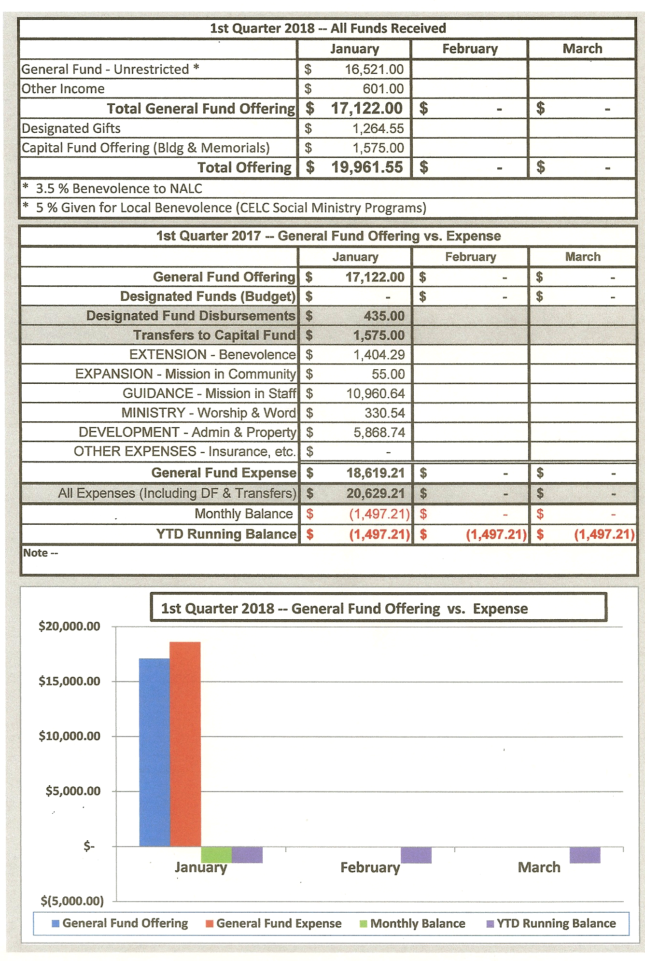

February 2018

|  |  |  |  |  |  |  |  |
| --- | --- | --- | --- | --- | --- | --- | --- |
| Sunday | Mon | Tuesday | Wed | Thursday | Fri. | Sat. | |
|  |  |  |  | 1 Food Pantry  11am-12:30pm | 2 | 3 | |
| 4  Sunday Schoo  9:30am  The Divine Service 10:30am  Church Council Meeting  6:30pm | 5  Cemetery Meeting at Harper Park Gym  6pm | 6 | 7  Bible Study 5:30pm  Choir practice  7:00pm | 8  Food Pantry  11am-12:30pm | 9 | 10 | |
| 11  Sunday School  9:30am  The Divine Service 10:30am | 12 | 13  Women’s Bible Study  10:00am  Assisting Ministers  Instruction  6pm | 14  Ash Wednesday Community Service 12:00 noon  Ash Wednesday Evening Service  7:00pm/no meal | 15  Food Pantry  11am-12:30pm | 16 | | 17 |
| 18  Sunday School  9:30am  The Divine Service 10:30am | 19 | 20 | 21  Meal – 5:45-6:30pm  Lenten Service 7pm | 22  Food Pantry  11am-12:30pm | 23 | | 24 |
| 25  Sunday School  9:30am  The Divine Service 10:30am | 26 | 27 | 28  Meal – 5:45-6:30pm  Lenten Service 7pm |  |  | |  |

The New Office Hours for 2018 are 8:30am – 1:00pm.

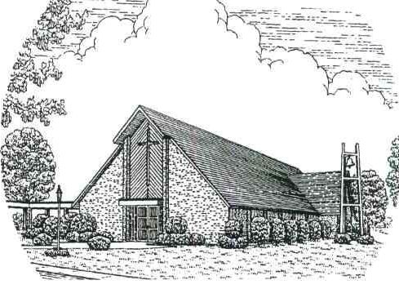

**Christ’s Evangelical Lutheran Church**

203 S. Main St. Stanley, NC 28164

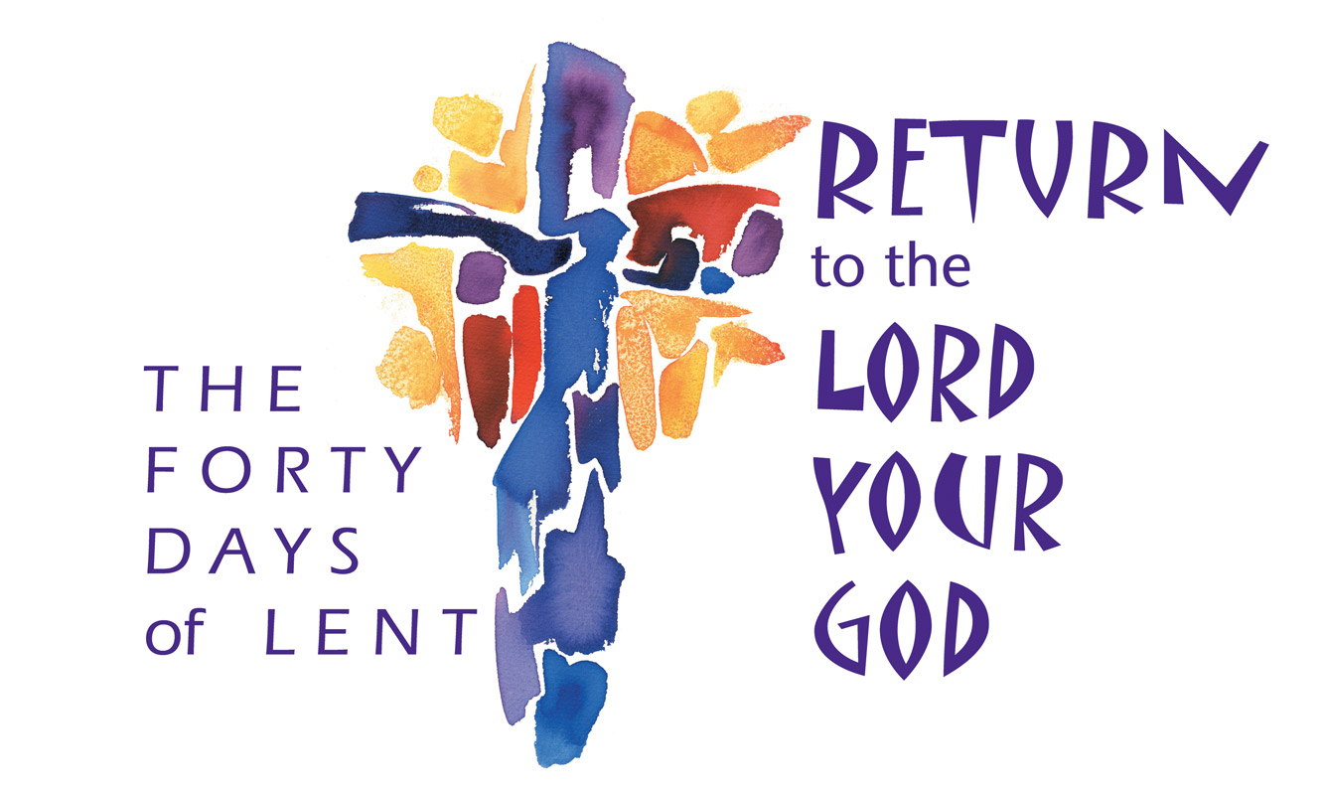

**Schedule:**

**Sunday**

9:30am Sunday School

10:30am Worship Service

**Wednesday**

5:30pm Bible Study

7:00pm Choir Practice

**Church Office Hours:**

Monday—Friday 8:30am until 1:00pm

CELC

Newsletter

February 2018

Pastor: Rev. Wesley R. Frye, STS

Administrative Assistant: Julie Bodenheimer

Facilities: Rick Chapman