|  |
| --- |
|  |
| Lutheran RoseJanuary 2018  CELC Newsletter  **Christ’s Evangelical Lutheran Church**  **Church Website: www.celcstanley.com** |
|  |

**Pastor’s Message:**

On Jesus, the *founder* and *perfecter* of faith.

Grace to you and peace from God our Father and the Lord Jesus Christ.

After a rather long praising of the heroes of the faith in ch.11, the writer of Hebrews makes a reference to Jesus as “the founder and perfecter of faith” near the beginning of ch.12.

Firstly, we notice that here two words are contrasted—“founder” and “perfecter”. “Founder” (“archegos” in Greek) has as its root “arche” which means “beginning”. “Perfecter” (“teleotes” in Greek”) comes from the root “telos” which means “end”. The use of these two words here indicates that a strong contrast is being set up. In fact, this combination of “founder and perfecter” is similar to Jesus’ own self-identification in Revelation—“**I am the Alpha and Omega**” and “**I am the first and the last**” “…**the beginning and the end**”.

Secondly, in discerning what it means that Jesus is the *founder* and *perfecter* of faith, we need to ask the question: In what sense does *Hebrews* call Jesus the “founder” of faith? As I mentioned above, “founder” translates the Greek noun “archegos” –a word which relays the sense not of a director or manager, but rather of someone who actually “begins” a work. A manager may be an overseerer of a thing but he is not necessarily the cause of it. Such a meaning of “archegos” is consistent with the one other place Hebrews uses the word in reference to Jesus, “**For it was fitting that he, for whom and by whom all things exist, in bringing many sons to glory, should make the founder (archegos) of their salvation perfect through suffering**. (Heb. 2.10)

The depiction of Jesus as “founder/archegos” almost certainly comes from the content of the Apostolic preaching—that is, this is simply the way the Apostles were preaching about Jesus. St. Peter uses the word twice in reference to Jesus, calling him the “**Author (archegos) of life**” and proclaiming that, “**God exalted him at his right hand as Leader (archegos) and Savior**…”. As Jesus initiates both “life” and “salvation” he also initiates faith. As the author of Hebrews describes it, Jesus does this by going out before believers to show them how and where to run: “…let us run with endurance the race that is set before us, looking to Jesus…” This faith he modeled chiefly in his Passion in that he “endured the cross and despised the shame” (12.2). He looked to his Father’s will and submitted to it. This is simply to say that Faith trusts in God no matter the cost. This is also to say that faith is God’s work. It is not something that we muster up in ourselves by our intellectual maneuvers.

Third, Jesus is the “perfecter” of faith in that he brings to its conclusion and completion the faith manifested by those many Old Testament heroes that were just celebrated in the previous chapter of Hebrews (ch.11). He makes perfect those who preceded him in the faith and all those who will come after him. The saints of the Old Testament had faith of course, but it was not complete and thus it was not perfect as the author of Hebrews declares: **And all these, though commended through their faith, did not receive what was promised, since God had provided something better for us, that apart from us they should not be made perfect**. (11.40)

This perfection accomplished by Jesus is not a “shot in the arm”, a “supplement”, an “addition” tacked on to the faith of our ancient brothers and sisters. In much the same way that the relationship between “not perfect” and “perfect” is not simply quantitative alone, so the difference between New Testament faith and faith in the Old Testament is not merely a matter of “more or less”. The difference is *qualitative* *and of a different order* altogether. This of course is why Hebrews begins with this qualitative distinction: **In many and various ways God spoke to his people of old by the prophets, but now in these last days he has spoken to us by his Son.** The comparison is not just between apples and oranges, it’s between incomplete and complete, imperfect and perfect, faith made complete in the Messiah, and faith that is not. And so Jesus says without hesitation, “**No one comes to the Father except through me.”** (John 14.6)

What all of this means from this short little verse in the Book of Hebrews is that we don’t need to rely on ourselves to do the heavy lifting. Faith is something that Christ begins and ends because he is its founder and perfecter, its beginning and end. There have been many times (countless times) over the past year in which I have found myself generally weakened and wearied from simply living life in a fallen and broken world. If I had to rely on *myself*, on *my faith*, on *my resolve and intellectual capacity* to get me through those times and to pull me up by the bootstraps, I would be crushed under the immense weight of it all. Nevertheless, in Jesus I have a Savior who not only goes out before me, but also walks with me. When I am weak, he makes me strong. When I am lacking, he fills in the void. I don’t need to strive or contend for anything. He is everything *to me* and *for me* that I cannot be or accomplish in and of myself. Or in the words of the Lorica of St. Patrick: *Christ before me, Christ behind me, Christ above me, Christ beneath me, Christ on my right, Christ on my left, Christ when I lie down, Christ when I sit up…* Christ at all times my companion, friend, founder and perfecter. He is my very atmosphere.

As we head into another year with all of its unknown challenges, remember that Jesus, the founder and perfecter of faith, goes before you and that in him, with him, and through him, you are never needful of anything.

God bless you in his new year of 2018 +Pastor

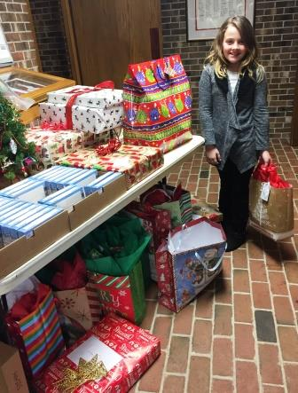

**Blessing of the Home on (or around) the season of Epiphany**

...has long been a custom in the Christian Tradition. If you would like for the Pastor to come and bless your home please give him a call to set up a time.



Adopt A Residenct was a time of sharing with older residents at Total Living Center for Christmas.

Thanks to all who chose that special someone and purchased gifts.  God Bless you for your kindness.



Prayer Concerns

|  |  |
| --- | --- |
| Immediate Care Concerns:  Grieving: | Bertie Billups,Tyree Bost, Richard Smith, Susan Wyatt, Eddie Wyatt, Lindy Hawley, Christine Wallace, Gaynelle Moore, Lenore Lay, Pearl Summey, Libby Michael, Jimmy Harrison    The Pastor Harvey Mozolak family (Pastor Harvey’s Dad, Samuel)  Pat Ritchie, Eleanor Abernathy, Judy Abernathy (sister Juanita Hovis)  The Eileen Mozolak family (Eileen’s brother Doyle Janssen) |
| Home-bound Members: | Ruth Cloninger, Gaynelle Moore, Phyllis Hawley, Pearl Summey, Lindy Hawley |
| Members in Nursing Homes: | Lenore Lay, Edna Lineberger (502 B), are in Stanley Total Living Center, Christine Wallace is at Huntersville Health & Rehabilitation  Center, 13835 Boren St. Huntersville, Sarah Lewis is in Wilmington. |

Friends and Relatives:

Everette Lineberger Jewel West Cindy Turry Bob Stewart Chris Davidson

Ann Lineberger Eddie Rhyne Jennifer Champange Betty Jones Harry Murphy

Karen Scrivani Joe Canipe Tom Hodge Steve McAlister Bob Hilton

Ron Ritchie Tom Olls Wanda Murphy Amy Blythe Robert Caskaddon

January Birthday’s

15 Eleanor Abernathy

19 Sarah Lewis

23 Pearl Summey

24 Hubert Abernathy

25 Gail Weathers

27 Teri Hedrick

3 David Lewis

3 Pat Ritchie

3 Rachel Walker

9 Wesley Clark

9 Leonard Lewis

14 Kimberly Benedict

14 James Bodenheimer

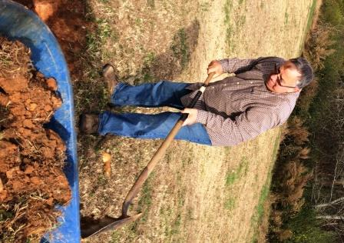

Bud Abernathy & Pastor Frye planting our tree that was dedicated on the 500th anniversary of Reformation.

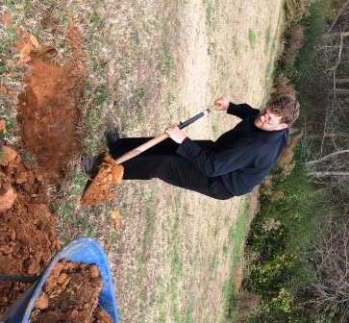

Anniversary

31 Bud & Judy Abernathy

Baptism Anniversary

1 Anne Chapman

1 Wayne Davis

1 Loretta Lewis

1 Edna Lineberger

1 Pat McAlister

1 Tammy Poarch

1 Tonya Stone

28 Jill Price



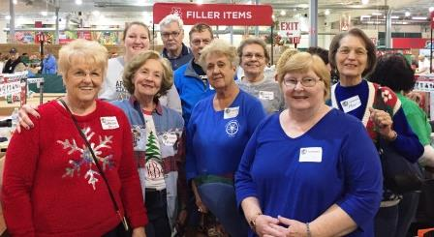



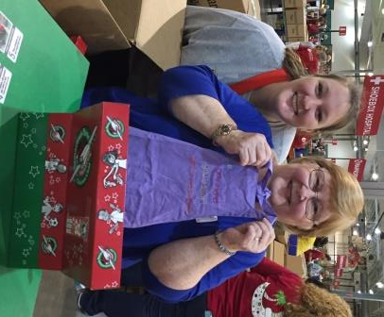

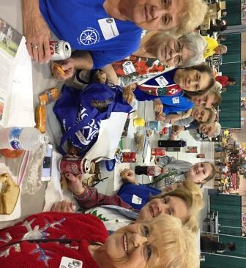

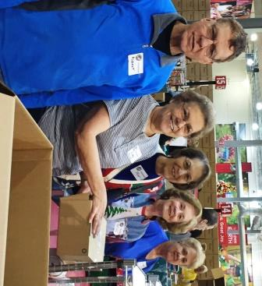

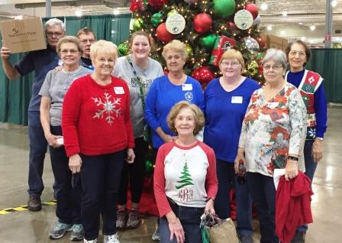

Ten people worked at Operation Christmas Child on Monday in Charlotte.

A most rewarding experience and fun time together.  The time goes so fast working on the boxes and then its break time and Charles always brings homemade cookies!

Yummy for us.  After our four hour shift we enjoyed lunch at Salarita's before heading back to Stanley.  Thanks to all who donated boxes and everyone who volunteered time at the packing center.

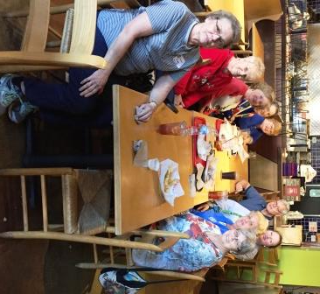

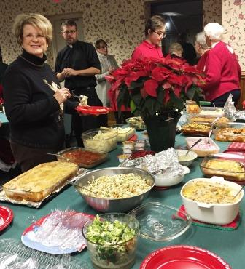

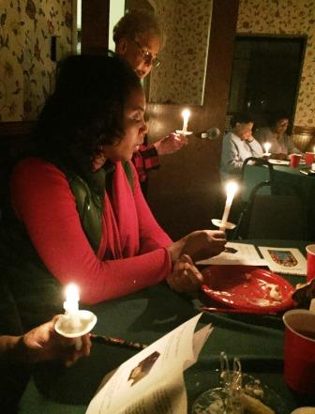

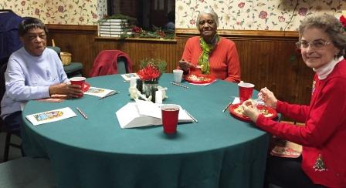

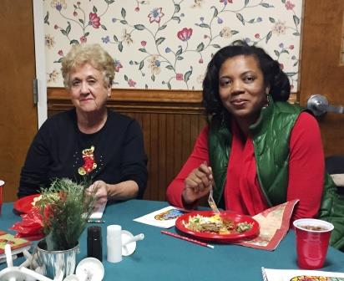

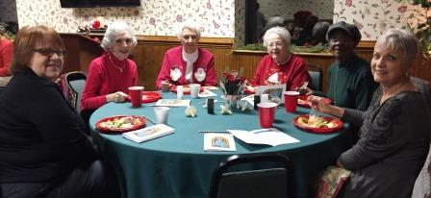

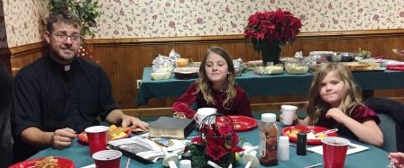

Fellowship and dinner with Mt. Pleasant Ladies is an annual event especially arranged by our Doris Cope. So much delicious food to enjoy then Christmas Carols to sing and scripture about the baby Jesus to be born.

There was Love and caring shown to each other this special time of year.

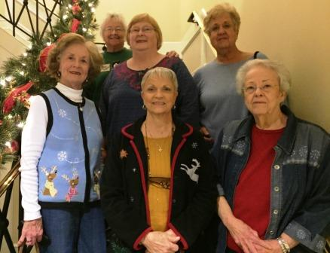



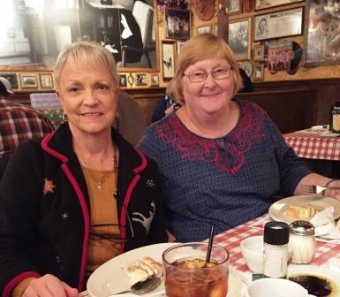

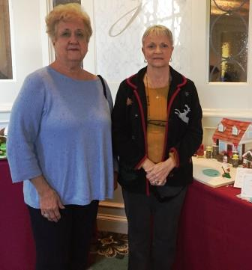

What talented people that create "Gingerbread Houses".... so many were children too!

A fun day with LOTS of laughs together!  Great lunch and that dessert required a mighty BIG spoon!

Ladies from CELC --  we always have a great day out... join us next time!

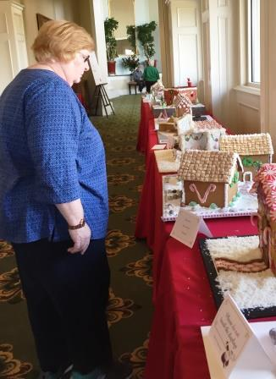



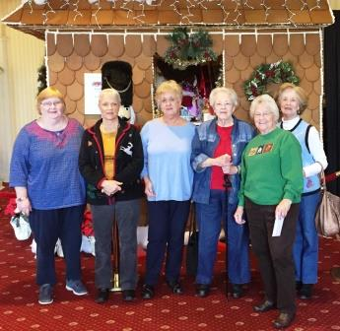

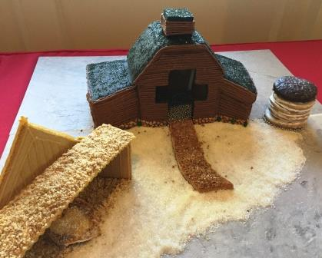

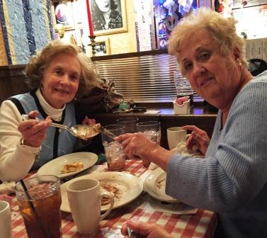

First snow of the season didn't keep these "25" Prime Timers from enjoying the evening together in Christmas celebration!

We celebrate the greatest gift ever  ...  the birth of our Lord and Savior.

Good food, great fun and fellowship always for this group.  Merry Christmas and Happy 2018!!

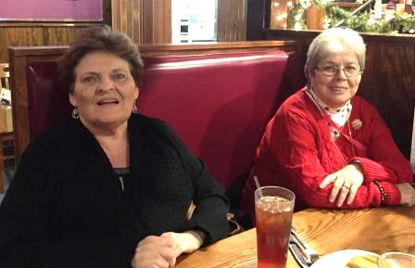

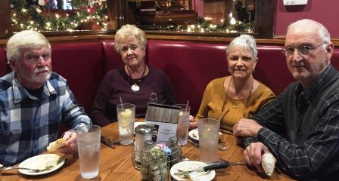













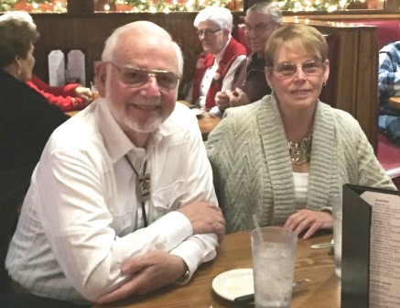

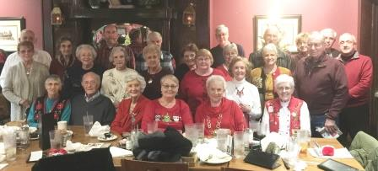

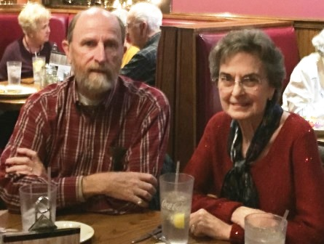

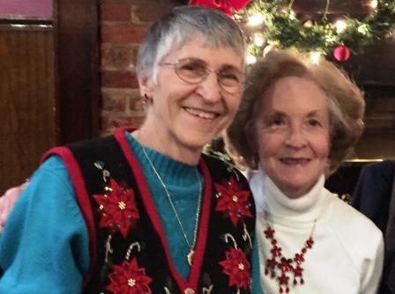



Hanging of the Green was a wonderful service decorating the church for the season of Christmas.

Many talented members took part in the preparation for the coming of the King.

A joy to hear little Carter (Rick & Anne Chapmans’ Grandson) sing and the excitement of all the children.

Thanks to so many for sharing your time and talent in the grand celebration.

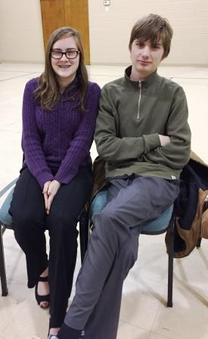

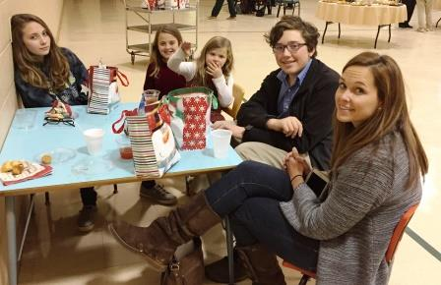

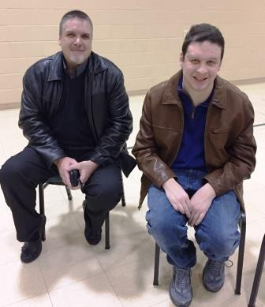

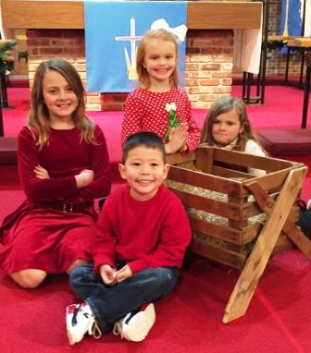

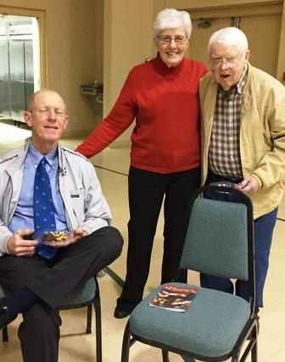

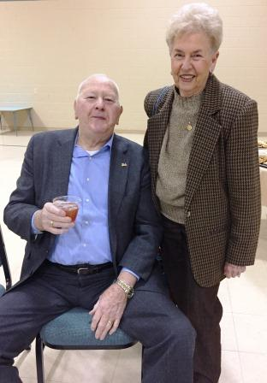

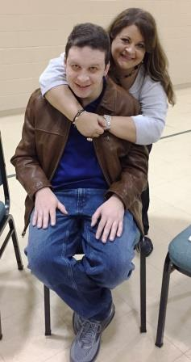

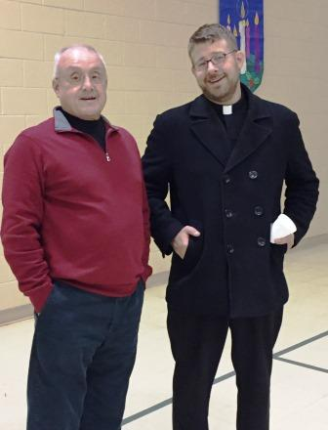

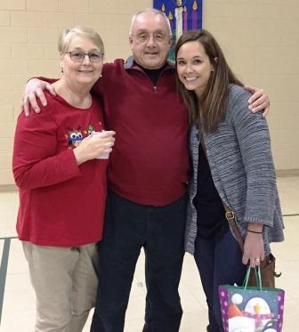

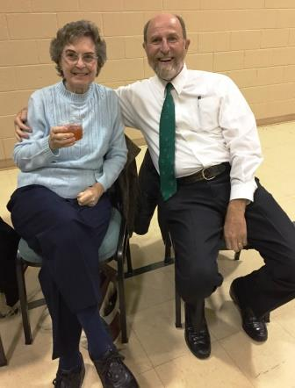

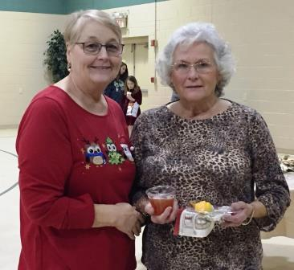

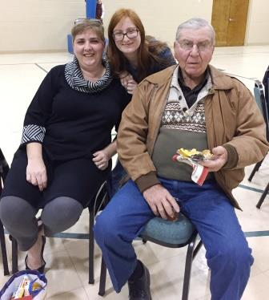

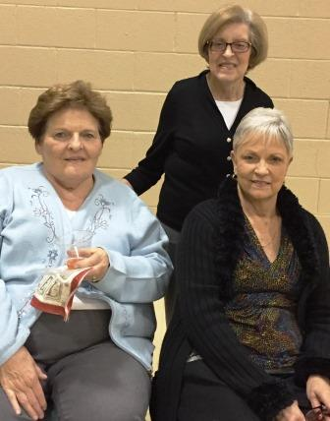

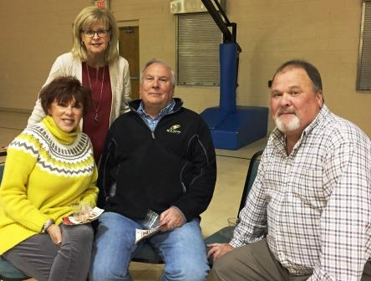

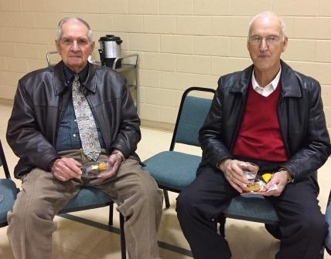

**A Note from the Church Council President**

A New Year brings New Year’s Resolutions, plans and often advice. I read this article and thought I would share it with you.

Live beneath your means. Return everything you borrow. Stop blaming other people. Admit when you make a mistake. Give clothes not worn out to charity. Do something nice and try not to get caught. Listen more, talk less. Everyday take a 30 minute walk. Strive for excellence, not perfection. Be on time. Don’t make excuses. Don’t argue. Get organized. Be kind to unkind people. Let someone cut ahead of you in line. Take time to be alone. Cultivate good manners. Be humble. Realize and accept that life isn’t fair. Know when to keep your mouth shut. Go an entire day without criticizing anyone. Learn from the past. Plan for the future. Live in the present. Accept what is. Let go of what was. And have faith in what will be. Don’t sweat the small stuff. It’s all small stuff. (By David Wolfe)

**For I am about to do something new. Isaiah 43:19**

Wishing you all a happy and healthy 2018.

Judy Abernathy

Council President

**Special message for all CELC members, cemetery plot-owners, family members of cemetery plot owners and all friends of our church.**

There will be a **CELC meeting** for Church members and friends of the Church to discuss important topics effecting the cemetery on **Sunday**, **January 21, 2018, at 3:00 p.m**. in the Church Sanctuary.

As you may have heard CELC will be making a presentation before the Town of Stanley Council on the first Monday in February (6:00 p.m., February 5, 2018,) concerning the continual financial maintenance responsibility of the cemetery grounds. In preparation for that presentation to the Town Council meeting our Church Cemetery Committee will present information to CELC members and friends of the Church on **Sunday**, **January 21, 2018, at 3:00 p.m** about the following:

* + The planned presentation to the Town of Stanley
  + Proposed cemetery boundary changes in preparation for our application to the State of North Carolina to request the entire cemetery be designated as an historic site.

Your attendances at both at the Church meeting and at the Town Council meeting are very important and would be greatly appreciated.

**We welcomed 6 new members to our church family on Nov. 5, 2017. Faye Tompkins, Sheila Saunders, Anne Fields, Gil Harris and Mike & Judy Bozeman. There will be a bio for Mike & Judy in our February’s newsletter.**

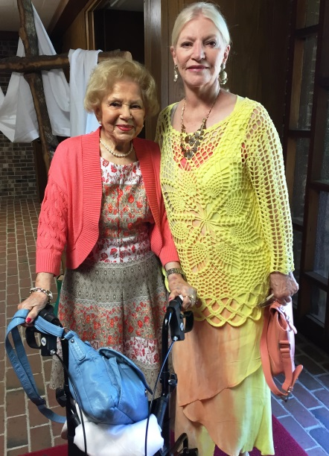 Faye Tompkins and her daughter Sheila Saunders became members of our church on November 5, 2017. Faye lives in Mt. Holly but is a native of Damascus Virginia. Faye has two daughters, two grandchildren and two great grandchildren. She is now retired but worked at Sodyeco, Kimbrell’s Furniture, and Carothers Funeral Home. She was voted Mt. Holly Woman of the year in 1999. She graduated Paw Creek High School and is a certified Stephen Minister. Her interests are reading and traveling.

Faye’s Daughter Sheila Saunders lives in Stanley, North Carolina. She is retired and was a Social worker in Wilkes and Gaston Counties and a school counselor at Stanley and Crest Middle School. Sheila has two children and two grandchildren. She graduated Mt. Holly High School and then attended East Carolina University where she got her B.A. in Psychology and then graduated Appalachian State University and received her M.A. in Guidance and Counseling. She is also a certified Stephen Minister. Sheila enjoys cooking, family history and going to dirt track races.

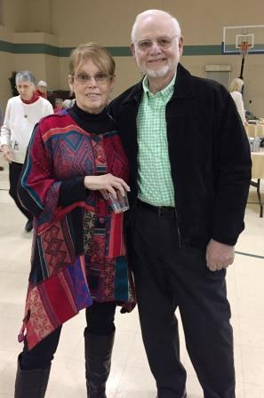 Anne Fields...For most of her life Anne has lived in Mt. Holly and attended Good Shepherd Lutheran Church where she was baptized and confirmed. Most recently she moved to Cramerton. Anne attended the Mt. Holly Schools. She went to Lenoir Rhyne University and while there, sang in the college choir. After graduating, she taught school in Norwood for 1 year, then returned to Mt. Holly and taught at Ida Rankin School for 38 years. Anne has 2 children. Anne Lee, her daughter works for the Red Cross, and David her son is a programmer with Novant Health. She has 3 wonderful grandchildren. Two of them attend Gaston Christian School and one has already graduated from High School. She now serves as a church choir member, and she is a member of the Mount Holly book Club, and serves as a docier of the Mount Holly Historial Society.

Gilbert “Gil” B. Harris... Gil was born in Perth Amboy, New Jersey. He grew up and was confirmed at Our Redeemer Lutheran Church (LCMS). He spent many years as a Cub Scout and as a Boy Scout earning the rank of Eagle with Bronze Palms. While in scouting he worked through the requirements and earned the PRO Deo et PATRIA award (for God and Country). After High school he joined the Navy and spent time in Maryland, Florida, Asmara Ethiopia and Vietnam as a Seabee. After the service he worked for AT&T as a property manager for thirty years, then in New York at the World Trade Center for three years and spent ten years as the property manager for a school district. He has an adult son living in Washington State. He volunteered in multiple capacities during thirty-six years as a member of a credit union. He has served on the Board of Directors for twelve years, during which time he held the positions of Secretary, Second vice Chairman, First Vice Chairman and Chairman. He now serves as a church choir member, an operating member and vice president of the Metrolina Model Rail Road club, a Board member of his HOA and an operating member of the Cumbres and Toltec Scenic Rail Road. He moved to North Carolina to get away from the snow and taxes.

**Save the Date**

**Prime Timers**

**Saturday Night -- January 20, 2018**

**Leaving CELC at 6:15pm**

Let’s load up the cars and head to Captain’s Cap, Denver, N.C.!

Fish, Salad Bar and lots of conversion for this winter night.

Get your name on the list to go now!

Plan on “warming” the night with some pretty good friends!

**Wednesday Night Bible Study**

We will be starting our Wednesday Night Bible Study up again on Wednesday, January 17 at 5:30pm. If you’re like me and need a routine to form good habits, then you may want to consider coming to this Bible Study and make it a part of your weekly routine. Right now on Wednesday evenings we’re taking a look at The Augsburg Confession (what Lutherans believe) and the biblical basis for each doctrine which the AC lays out. Our study is not cumulative and doesn’t build upon each weekly lesson – or to put it another way: You can come right now and jump right in!

**Worship & Music Committee Meeting**

The Worship & Music Committee will be having a meeting on Tuesday, Jan. 16th at 7pm. If you are on this committee or interested on being on this committee please attend.

**Toilet Paper Drive**

The Women of the Church are starting a toilet paper drive for the food pantry. Please bring toilet paper and put on the table in the memorial corridor. Thanks

Thank You.

I would like to thank everyone so much for the cards, calls and gifts that you showered upon me and my family over the Christmas season. It is truly a blessing to be your Pastor through the good times in your lives and through the bad times as well. My family and I are so thankful to be a part of this community of saints.

God's Peace. +Pastor Frye

My family and I would like to thank the Martin Luther Class for the wonderful fruit basket and the Christmas Check. It really comes in handy at Christmas.

Thank you, Julie

Bill and I would like to thank the Martin Luther Class for the fruit basket.

Sincerely,

Doris Cope

In a most loving manner Christ’s Lutheran in Stanley attended, prayed for, sent cards, formed a choir, offered music for worship, helped with setting up the church building and ushering, provided a bulletin, served a wonderful and tasty dinner— all honoring my father, Pastor Samuel and caring for his family including a couple of folks who usually sit about half way back by the pulpit-wall side aisle.  And the parish’s pastor graciously shared your altar and pulpit so that one of that couple could celebrate and preach at his father’s funeral.  Thank you for your love, understanding and these and other gifts through the last several years and especially now.  In Christian love, Pastor Harvey and Eileen Mozolak

CELC Church Council 2018

**Title Name Phone Number Term / Email**

Pastor Rev. Wesley Frye (828) 381-7699

Email: [WesleyRFrye@gmail.com](mailto:WesleyRFrye@gmail.com)

President Judy Abernathy (704) 263-8258 (H) 3 Year - Expires 12/31/2018

(704) 813-6212 (C)

Email: [J10Abernathy@att.net](mailto:J10Abernathy@att.net)

Vice President Leonard Lewis (704) 263-8364 3 Year - Expires 12/31/2020

Email: [LeonardLLewis@bellsouth.net](mailto:LeonardLLewis@bellsouth.net)

Secretary Joe Keefer (704) 263-8155 3 Year - Expires 12/31/2019 Email: [JLKeeferDMD@bellsouth.net](mailto:JLKeeferDMD@bellsouth.net)

Treasurer Michael Dukes (703) 439-0005 (C) 1 Year - Expires 12/31/2018

(General Fund) (704) 263-2470 (H)

Email: [SquareDancers@earthlink.net](mailto:SquareDancers@Earthlink.net)

Treasurer Crystyl Human (704) 263-1369 1 Year - Expires 12/31/2018

(Capital Fund) Email: [CLHuman69@gmail.com](mailto:CLHuman69@gmail.com)

Financial Secretary Judy Cloninger (704) 263-4008 1 Year - Expires 12/31/2018

Email: [MandJCloninger@gmail.com](mailto:MandJCloninger@gmail.com)

**Council Liaison**

Archives &

Communications Richard Medlin (704) 263-9724 3 Year - Expires 12/31/2020

Email: [RichardMedlin43@gmail.com](mailto:RichardMedlin43@gmail.com)

Audit TBD

Christian Education Tonya Stone (704) 530-3717 3 Year - Expires 12/31/2018

Email: [TMStone@gaston.k12.nc.us](mailto:TMStone@gaston.k12.nc.us)

Endowment Joe Keefer (704) 263-8155 3 Year - Expires 12/31/2019 Email: [JLKeeferDMD@bellsouth.net](mailto:JLKeeferDMD@bellsouth.net)

Evangelism Crystyl Human (704) 263-1369 3 Year - Expires 12/31/2020

Email: [CLHuman69@gmail.com](mailto:CLHuman69@gmail.com)

Finance Tommy Hedrick (704) 827-4598 3 Year - Expires 12/31/2018

Email: [THedrick@hrblock.com](mailto:THedrick@hrblock.com)

Internal Ministry Prissy Helms (704) 674-2624 3 Year - Expires 12/31/2018

Email: [Prissy.Helms@dhhs.nc.gov](mailto:PrissyHelms@dhhs.nc.gov)

Mutual Ministry Pat McAlister (704) 854-0103 3 Year - Expires 12/31/2019

Email: (No email)

Nominating TBD

Property Brian Robinson (704) 622-1802 3 Year - Expires 12/31/2019

Email: (No email)

Social Ministry Judy Ray (704) 263-1459 (H) 3 Year - Expires 12/31/2018

(704) 747-8567 (C)

Email: [JudyandCharles@gmail.com](mailto:JudyandCharles@gmail.com)

Stewardship Leonard Lewis (704) 263-8364 3 Year - Expires 12/31/2020

Email: [LeonardLLewis@bellsouth.net](mailto:LeonardLLewis@bellsouth.net)

Worship & Music Nancy Olls (704) 718-9776 2 Year - Expires 12/31/2019

Email: [SopranoBadger@gmail.com](mailto:SopranoBadger@gmail.com)

Youth Laura Olls (919) 973-9382 (C) 1 Year - Expires 12/31/2018

Email: (No Email)

**Trust Officers**

Team #1 Leonard Lewis (704) 263-8364 2 Year - Expires 12/31/2018

Pat Ritchie (704) 735-4703 2 Year - Expires 12/31/2018

Team #2 Jay Human (704) 263-1369 2 Year - Expires 12/31/2018

Craig Poarch (704) 263-8726 2 Year - Expires 12/31/2018

Team #3 Terri Hedrick (704) 827-4598 2 Year - Expires 12/31/2019

Prissy Helms (704) 674-2624 2 Year - Expires 12/31/2019

Team #4 David Lewis (704) 263-8064 2 Year - Expires 12/31/2018

Barbara Benedict (704) 577-3204 2 Year - Expires 12/31/2018

**Food Pantry**

Director Nancy Dukes (704) 263-2470

Email: [NLDukes1110@gmail.com](mailto:NLDukes1110@gmail.com)

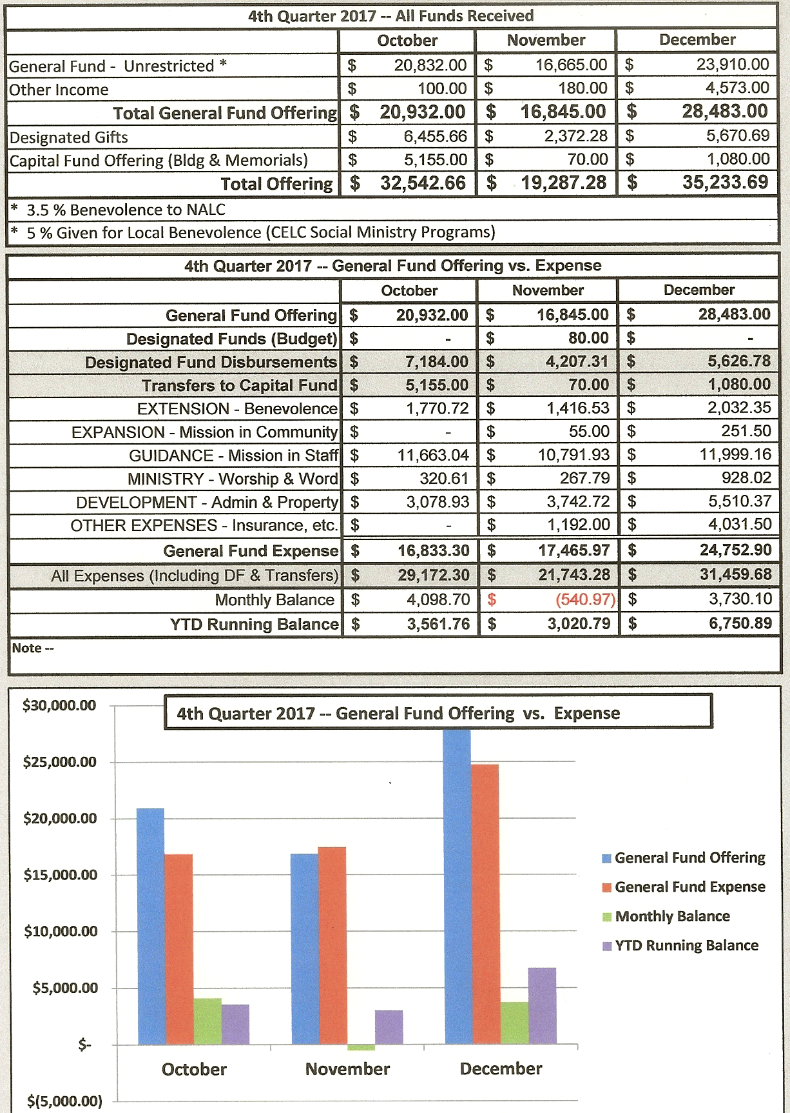

|  |  |  |  |  |  |  |  |
| --- | --- | --- | --- | --- | --- | --- | --- |
| Sunday  January 2018 | Mon | Tuesday | Wed | Thursday | Fri. | Sat. | |
|  | 1 | 2 | 3 | 4  Food Pantry  11am- 12:30pm  “Confession & Absolution”  12:30-1:30pm | 5 | 6 | |
| 7  Sunday School 9:30am  The Divine Service 10:30am | 8 | 9  Women’s Bible Study  10:00am | 10 | 11  Food Pantry  11am- 12:30pm  “Confession & Absolution”  12:30-1:30pm | 12 | 13 | |
| 14  Sunday School 9:30am  The Divine Service 10:30am | 15 | 16  Worship & Music Committee Meeting 7:00pm | 17  Bible Study 5:30pm  Choir Practice 7:00pm | 18  Food Pantry  11am- 12:30pm  “Confession & Absolution”  12:30-1:30pm | 19 | | 20  Prime  Timers Captain’s Cap Leaving CELC at 6:15pm |
| 21  Sunday School 9:30am  The Divine Service 10:30am | 22 | 23 | 24  Bible Study 5:30pm  Choir Practice 7:00pm | 25  Food Pantry  11am- 12:30pm  “Confession & Absolution”  12:30-1:30pm | 26 | | 27 |
| 28  Sunday School 9:30am  The Divine Service 10:30am | 29 | 30 | 31  Bible Study 5:30pm  Choir Practice 7:00pm |  |  | |  |

The New Office Hours for 2018 are 8:30am – 1:00pm.

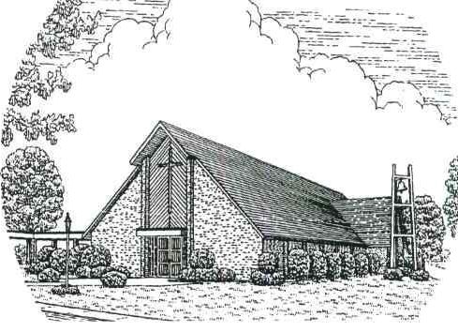

**Christ’s Evangelical Lutheran Church**

203 S. Main St. Stanley, NC 28164

**Schedule:**

**Sunday**

9:30am Sunday School

10:30am Worship Service

**Wednesday**

5:30pm Bible Study

7:00pm Choir Practice

**Church Office Hours:**

Monday—Friday 8:30am until 1:00pm



CELC

Newsletter

January 2018

Pastor: Rev. Wesley R. Frye, STS

Administrative Assistant: Julie Bodenheimer

Facilities: Rick Chapman