|  |
| --- |
|  |
| May 2018    CELC Newsletter  **Christ’s Evangelical Lutheran Church**  **Church Website: www.celcstanley.com** |
|  |

**Pastor’s Message**

**Acts 1:1-11**  **In the first book, O Theophilus, I have dealt with all that Jesus began to do and teach, 2 until the day when he was taken up, after he had given commandment through the Holy Spirit to the apostles whom he had chosen. 3 To them he presented himself alive after his passion by many proofs, appearing to them during forty days, and speaking of the kingdom of God. 4 And while staying with them he charged them not to depart from Jerusalem, but to wait for the promise of the Father, which, he said, "you heard from me, 5 for John baptized with water, but before many days you shall be baptized with the Holy Spirit." 6 So when they had come together, they asked him, "Lord, will you at this time restore the kingdom to Israel?" 7 He said to them, "It is not for you to know times or seasons which the Father has fixed by his own authority. 8 But you shall receive power when the Holy Spirit has come upon you; and you shall be my witnesses in Jerusalem and in all Judea and Samaria and to the end of the earth." 9 And when he had said this, as they were looking on, he was lifted up, and a cloud took him out of their sight. 10 And while they were gazing into heaven as he went, behold, two men stood by them in white robes, 11 and said, "Men of Galilee, why do you stand looking into heaven? This Jesus, who was taken up from you into heaven, will come in the same way as you saw him go into heaven."**

In the 1st chapter of Acts the risen LORD gives the last recorded command to his Apostles: “Do not depart from Jerusalem but wait for the promise for the Father”. There are 10 days in between the Ascension of Jesus and the subsequent sending of the Holy Spirit at Pentecost. In that time the Church does something that many today may very well forget to do while preparing to do the LORD’s work (or properly speaking, *cooperating* with the Holy Spirit): **Acts 1:14**  **All these with one accord devoted themselves to prayer, together with the women and Mary the mother of Jesus, and with his relatives.**

So they devoted themselves to prayer thus showing us a good model when considering all things but particularly the ministry of the Gospel.

In the Ascension of our LORD we see the Way through which heaven and eternity lies open to us. Before this event, heaven seemed lost and locked to the fallen race of Adam. As in Genesis, Paradise was closed to us; we were abolished and it was guarded by cherubim with flaming sword facing all directions to slay anyone who dared even approach. Now in Jesus though, we have seen heaven flung wide open, that after crushing the head of the ancient serpent he may lead us back into Eden; back into the true Promised Land, from which we were excluded by our sins.

In the Ascension every person who has been baptized into Jesus should be comforted with the promises of the Savior—but particularly when the Shepherd says, “**That where I am you may be also**”. This is the promise of the Church’s union with Christ its King and the cause for such imagery as the Church being the Body of Jesus and he it’s Head. Here we see the importance of Holy Baptism. It’s important to recall that our brothers and sisters in the Old Testament were only brought into their promised land (Canaan) after they crossed through the waters of the Jordan River. And who brought them through the Jordan? – God! Likewise, the freedom from Pharaoh’s bondage which God ordained for his people Israel involved passing through the Red Sea. It is still God’s business to bring US through life-giving water that grants and

assures us of our freedom from Satan and our place in the eternal promised land. Every baptized member of Jesus’ body should then shout and rejoice at the LORD’s Ascension as even the believers in the Old Testament did when they caught but just a glimpse of the LORD in his kingly majesty and glory. As the Psalm for the Ascension this year shows:

**Psalm 47** Clap your hands, all peoples! Shout to God with loud songs of joy! 2 For the LORD, the Most High, is terrible, a great king over all the earth. 3 He subdued peoples under us, and nations under our feet. 4 He chose our heritage for us, the pride of Jacob whom he loves. *Selah* 5 God has gone up with a shout, the LORD with the sound of a trumpet. 6 Sing praises to God, sing praises! Sing praises to our King, sing praises! 7 For God is the king of all the earth; sing praises with a psalm! 8 God reigns over the nations; God sits on his holy throne. 9 The princes of the peoples gather as the people of the God of Abraham. For the shields of the earth belong to God; he is highly exalted!

We too ought resound with joy at the Ascension because this is not only something that concerned Jesus, it concerns also all of the redeemed who are joined to him by Baptism and faith. What does the Psalm emphasize that God’s people ought to do for Him???? --SING!

The Ascension of Christ shouldn’t be viewed as merely a happy ending to a story about a really nice guy who suffered a great deal at the hands of his enemies. To consider it this way would be to consider it without its true profit. It’s so much more than that: If Christ our Head has entered into the heavenly Canaan --- the true Promised Land… then we know that most certainly we shall too. For unless you are in Sleepy Hollow it’s not proper for a body to be without its head. The Ascension of Jesus shows us where we too are going!

St. Paul, Romans 8 talks about the present state of life on earth as groaning in labor pains--“**but we ourselves, who have the firstfruits of the Spirit, groan inwardly [as with labor pains] as we wait eagerly for adoption as sons, the redemption of our bodies. 24For in this hope we were saved**.” The Scripture decribes our present age in terms of childbirth. We are being born into heaven, adopted as sons…

…Christ the Firstfruits is already there… he is the Head of the Body the Holy Church… And in birthing children (or animals) where the Head goes… guess what’s sure to follow soon after??? --the body.

We mustn’t find ourselves gazing after the ascended Christ with our jaws dropped and with puzzled looks on our faces like the disciples that day. We have something vital that the Apostles did not have at the Ascension— we have the Holy Spirit. How can we be certain of that? Because Jesus said so, and he is not a liar! Therefore, we know that when Christ ascends into heaven, we are not far behind. In considering the ascended Christ we must see ourselves triumphing in him, making the Savior’s whole work on earth the basis for our trust, hope and joy.

When we fell into disgrace, our entire race came under the power of three terrible enemies—sin, death and the law. These do not act independently of one another (as if they were three dictators of three different countries)—they act in conjunction with one another and bind us as with one chain. (Like Tolkien’s ‘one ring to rule them all’.) For they rule together a common country—Hell, and they’re always looking for more citizens—there are no immigration laws in Hell… the borders are always open.

Listen to the way the Apostle describes this binding, "**The sting of death is sin; and the strength of sin is the law."**  Sin, Death, and the Law –the three great weapons of the enemy against us.

These three have acted as sandbags weighing us down to the bottom of the bottomless pit—which is where we rebellious creatures… darkened by sin… belong—infinitely apart from the goodness and righteousness of our God. No human power was able to conquer these things, in fact ironically when we attempted to free ourselves by our own striving… the bags would only get heavier and heavier. Because we’d look at ourselves and then our neighbor and say, “*Oh look how good I’m doing… but you _[insert whoever]_ you are still doing awful things, you’re a miserable sinner… what have you done?* And our pride would swell and so would our confidence in our own abilities. And in this way we’d become even more strongly bound and shackled by these three.

However, thanks be to God that he would *not* have this for the creatures he loves. Our Savior sets us free from the hands of our enemies. Where Sin, Death and the Law reigned---The Son was made to be **Sin** for us; it’s he who submitted to **the Law** in our stead when we couldn’t; it’s he who turned his face towards Jerusalem to die the **Death** that we deserved. He has conquered sin, death and the law for us. And when Christ rose victoriously from the dead the entire fallen world triumphed with him. Hell was spoiled, Death made but a shadow, the Law lost its power to accuse and condemn --life and immortality have been brought to light.

All our enemies lay slain at the feet of him who came to give Himself for us.

And now only one thing remains for Christ to accomplish. After he had slain our enemies he must ascend to glory—the rod of omnipotence and dominion must be given to the God-man. He sits at the right hand of power and has become the absolute LORD over Sin, Death, Hell. In his Person, he has made our flesh to triumph over these things and it’s for this reason that Jesus ascends to divine glory. If we want to think of the Ascension of Jesus rightly, we must view Jesus as the substitute and then forerunner of the entire fallen race of Adam.

Typologically we see this in David when he killed the giant Goliath. Because David is a type/representation/figure of Jesus. So just as all Israel was delivered from the hands of the Philistines through the single victory of David….. so all sinners are delivered from the Law, Sin and Death through the victory of our Ascended LORD. As David ascended the throne and gained dominion over all of Israel, so all authority is given over to the Man, Jesus Christ, to where the Psalm is truly about him: **8 God reigns over the nations; God sits on his holy throne.**

And now as certainly as no sin can any longer harm Christ, no law condemn him, nor death rule over him, now certainly those united to him enjoy the same freedom and dominion as their Head. They are freed from their prisons and his victory belongs to them! Truly *through Him* they are more than conquerors. And so when Satan seeks to use our sin and the Law against us to drive us back into our former dungeons, all we need to do is look in faith to the Ascended LORD and say, “Sin you are conquered and defeated, and as *my* captive all you can do is make me cling all the more firmly to Christ my Savior. For I no longer receive my sentence from sin and the law, my sentence comes from my ascended Savior and LORD and he is my Head and I his Body, and I know that where my Head goes I am most surely to follow, for he has promised me: Where I am, you will be also.

Wednesday Night Bible Study

The Book of Revelation

beginning May 16th

From very early on in the Church the Apocalypse of St. John (Revelation) has been somewhat of a difficult book to understand. We will be walking through this book together –slowly- and during that walk, we will see how beautifully the Gospel of our Lord Jesus Christ is presented to us over and over again!

**\*Who - You and whoever you’d like to bring!**

**(kids are always welcome at any Bible Study at Christ’s Lutheran!)**

**\*When - Wednesday Evenings @ 5:30**

**\*Where - Family Life Center**

**\*Why - To study God’s Sacred Word**

**\*How- By the power of the Holy Spirit**

Prayer Concerns

|  |  |
| --- | --- |
| Immediate Care Concerns:    Grieving: | Hubert Abernathy, Bertie Billups,Tyree Bost, Lindy Hawley, Christine Wallace, Gaynelle Moore, Pearl Summey, Libby Michael, Jimmy Harrison, Richard Smith, Susan Wyatt,Eddie Wyatt, Linda Cloninger  The Robinson Family (Eleanor Abernathy, Pat Ritchie & Judy Abernathy’s sister, Vivian R. Lineberger) |
| Home-bound Members: | Gaynelle Moore, Phyllis Hawley, Pearl Summey,Lindy Hawley |
| Members in Nursing Homes: | Edna Lineberger (502 B), is in Stanley Total Living Center, Christine Wallace is at Huntersville Health & Rehabilitation Ctr.,13835 Boren St. Huntersville, Sarah Lewis is at Carillon Cramer Mountain (Room C-2). Ruth Cloninger is at Carillon in Lincolnton |

Friends and Relatives:

Everette Lineberger Jewel West Cindy Turry Bob Stewart Chris Davidson

Ann Lineberger Eddie Rhyne Jennifer Champange Gail Conner Harry Murphy

Karen Scrivani Joe Canipe Tom Hodge Steve McAlister Eleanor Flowers

Ron Ritchie Tom Olls Wanda Murphy Amy Blythe Robert Caskaddon

Bob Hilton Rod Rudisill

**Seventh Annual 2018 Communitywide Tent Revival "under the stars at COMMONGROUND, 5481 Hickory Grove Road, Stanley, N.C. 28164**

**Tuesday evening, May 15 through Sunday evening, May 20, 2018**

**7:00 p.m. each evening**

**THEME:  SEE! MAKING ALL THINGS NEW**

April Birthday’s

22 Pastor Frye

22 Haley Hawkins

22 Gaynelle Moore

24 Betty Hacker

27 Tammy Poarch

2 Anne Chapman

3 Gary Dixon

4 Ashley Clark

15 Teresa Davis

20 Richard Hovis

Anniversary

11 Gary & Connie Dixon

28 Michael & Barbara Benedict

Baptism Anniversary

8 Nina Hovis

21 Judy Ray

24 Will Clark

29 Chase Clippard

29 Danielle Clippard

30 Lori Spears

12 Kimberly Benedict

13 John Clark

19 Alyssa Poarch

21 Craig Poarch

**Upcoming Events**

**Toilet Tissue Drive**

The Women of the Church are starting a toilet paper drive for the food pantry. Please bring toilet tissue and put on the table in the memorial corridor.

**Church Council Meeting**

There will be a church council meeting on May 22nd at 6:00pm. All church council members please plan to attend.

**Women’s Bible Study**

The Women’s Bible Study will be on May 8th at 10am in the Fellowship Hall.

**Prime Timers Event --- Sunday --- May 27, 2018**

**Fun and Pizza**

**Leaving CELC at 12:15 pm**

Lunch and Sunday afternoon together at the old homeplace in Statesville.

There will be one glorious sound going on with some old friends.

Make it your way Pizza! My brother Ernie will cook it in his outside brick oven!

Lorraine, my sister-n-law will have the crust ready and we will take everything for the salad bar … this is going to be good! Delicious desserts too! Be thinking on what you want to bring and I’ll have a sign-up list soon. Be sure and wear outdoor clothes and bring your lawn chair for a great time. Sign-up now so we can plan on transportation and food just let Mary or Kathey know asap!

****Dear Church Family,

**Thank you so much for the many kindnesses and expression of love and caring you gave to our family during the sickness and death of Vivian Robinson Lineberger. Vivian was a beloved sister, sister-in-law and aunt and will be sorely missed by all our family.**

**Sincerely,**

**The Robinson Family**

A fun Friday afternoon playing indoor putt-putt with some hole-n-ones by a few people with a little luck! Two will return for a free game for hitting the "prize hole" ... just guess by the pictures who that may be? A beautiful place by the river for supper and good Friday Night Fish at Catfish Cove.  Yummy and the Key Lime Pie wasn't bad either.



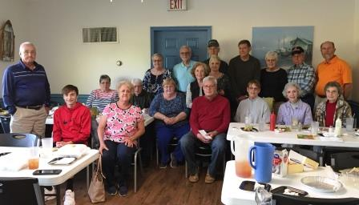



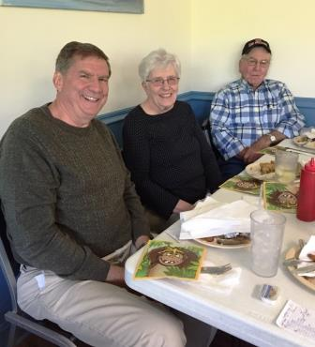



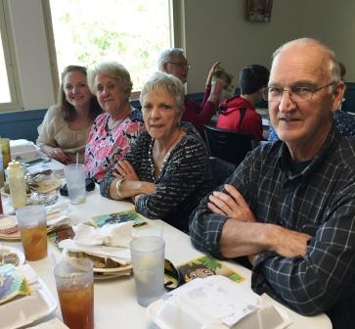

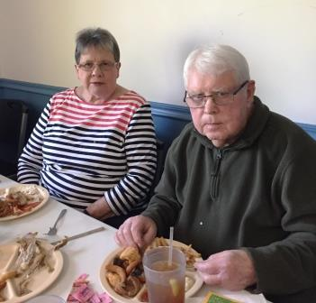





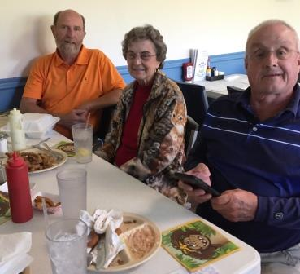

**Ladies Evening Together -- Sunday, June 3rd, 2018 -- 5:15 PM**

**Parade of Tables/Hee Haw Entertainment**

**Stanley Pentecostal Church -- Church Benefit**

A fun filled evening with a meal and many laughs are waiting for us to enjoy at a local church right here in Stanley. This is a fundraiser to help the Pentecostal Church purchase lighting for their Easter Program (I know alot of you have attended that program before).

Great way to be together and help out a very good cause. The doors to the building open at 5:15pm and meal at 6pm. The Hee Haw Program will be a blast too. We need to reserve our tickets/table now -- tickets are $25.00 each. Please let Mary or Kathey know this next week. Come join us! Plan on having a belly full of good food and lots of laughs. You will laugh more than normal because the Hee Haw characters are people you know! Men you are welcome too!



The

Lamb Award

“Feed my lambs.” John 21:15

**THE EMBLEM**

The Lamb Award is a national recognition bestowed on Lutheran adults by the National Lutheran Association on Scouting in conjunction with the National Lutheran Church Youth Ministry Departments.

**THE PURPOSE**

The purpose of The Lamb Award is twofold:

1. To acknowledge the distinguished service of Lutheran adults in fostering the spiritual growth of youth through church and civic youth serving agency programs (Boy Scouts of America, Girl Scouts of the U.S.A., American Heritage Girls, Camp Fire USA, and 4-H);
2. To increase the use and quality of the civic agency programs in Lutheran congregations as a part of their ministries with youth.

**ELIGIBILITY**

A Lamb Award recipient should:

1. Be an active member of a Lutheran congregation.
2. Have a minimum of 10 years of distinguished volunteer service to the church.
3. Have a minimum of 10 years of distinguished volunteer service to one or more civic youth agencies.
4. Serve as a Christian role model and leader to young people encouraging them to participate in the spiritual life of their congregation.
5. Promote the religious growth programs, the observance of Boy Scout, Girl Scout, AHG or Camp Fire Sunday, chaplains and chaplain’s aide program.
6. Exhibit leadership and be fully trained in the civic youth agency.
7. Help organize new units in the nominee’s own and neighboring Lutheran congregations.
8. Recruit youth and promote full involvement of members in the program.
9. Encourage units to support group service projects in response to a community or congregational need.

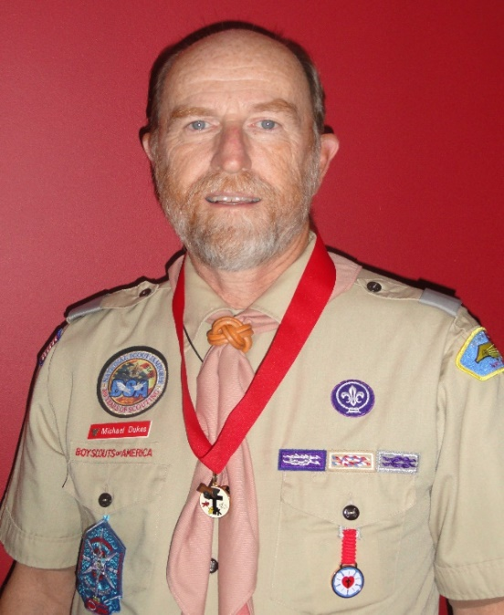

**Michael D. Dukes**

Michael has been involved in Scouting since 1965. As a youth, he earned his Eagle Scout Award, and has continued his involvement with Scouting ever since. He is a life member of the National Eagle Scout Association (NESA). He earned his Pro Deo Et Patria religious emblem in

1969 as a Scout, and in 1999 he was awarded the Servant of Youth (Adult Religious Award - Lutheran Church). He completed his Wood Badge in 2001. In 2001, 2005, & 2010 he served on

staff at the National Scout Jamboree.

Since moving to Stanley, NC in 2006 Michael has served as the Unit Commissioner for

both Pack 49 and Troop 49 which are chartered by First United Methodist Church-Stanley. As

Unit Commissioner, he has played an active role with the Pack and Troop; attending numerous campouts and camporees. One summer he served as an adult volunteer for a week at summer camp. He is often present at the regular Pack and Troop meetings as well as the monthly

Committee meetings. He has served on numerous Boards of Review, including several Eagle

Boards.

In addition to his service to Scouting, Michael has also been an active member in the

Stanley community. He has served as the Treasurer of Christ’s Lutheran since 2010. Recently,

he was the project lead for a building renovation for United in Action of Stanley Churches

(UASC) where he has served as Treasurer since the founding of the organization. UASC is an organization whose membership is composed of approximately 16 Stanley community churches

and several other community service organizations. He sings with the Stanley Community Choir.

In 2016, he started serving as a volunteer driver and handyman for FaithHealth-Gaston, an organization that provides assistance to those living in Gaston County, most of whom have

health issues and have no support system at home.

Michael has been a member of a Lutheran Church since his baptism at the age of 6. Prior to moving to Stanley, NC in 2006, he was a member of Holy Cross Lutheran Church in Herndon,

VA where he joined when he and Nancy were married in 1990. He sang in the choir and served

as an assisting minister for many of those years. He served as the Assistant Treasurer for payroll from 1996 to 2006; served on the building committee during the addition of an education wing, and served two terms on Church Council as the Personnel Ministry Chair. Michael retired in 2004 from VISA where he spent the last 12 years of his career as a Service Delivery Manager in the Computer Operations Division. He also enjoys camping, hiking, square dancing, golf, and playing bridge.

“No Greater Love”

With Memorial Day approaching, our thoughts of our veterans, and especially those who have given their lives for our country, become more frequent…



We certainly owe them more than temporarily remembering them, but also taking time to show respect and honor what they have done to either help build our community and/or preserve our freedom. This is a good time of year to take the opportunity to honor our ancestors, as well as our veterans, by supporting the Stanley Cemetery Ancestry Fund. The Fund is dedicated to maintaining the final resting place for our loved ones. When we pull together as individuals and as a community we can do amazing things. Many people know that if we contribute substantially to the Stanley Cemetery Ancestry Fund we are supporting an organization that has a mission of preserving the dignity of those we desire to honor. We can help by supporting a perpetual care fund that will ensure that our veterans and loved ones will never be forgotten and will always be cared for in their final resting place - even after we’re gone.

God bless our United States of America

**Christ’s Evangelical Lutheran Church**

**Cemetery Committee Report**

**ATTENTION ALL FAMILIES WITH RELATIVES IN THE STANLEY CEMETERY!** We are planning a new program of remembrance for this Memorial Day and every Memorial Day henceforth. Let us call your attention to a very important question and some very important information.

**WHO IS TAKING CARE OF YOUR ANCESTOR’S CEMETERY PLOT?**

Many years ago when your ancestors, great ancestors, great great ancestors passed away there was a belief that the loved ones would never leave them and would take care of the burial site. So a perpetual care fund was never created because it was felt there was no need for it.

For a long time, family members and friends did take care of the grave sites of those they loved and respected. Sadly, for those in the cemetery as our society became more mobile some people moved away, or other family issues came about, therefore the burial sites were left unattended.

For the last few decades the Town of Stanley was the primary organization to maintain the grounds in the historic Stanley Cemetery. In the year 2017 that came to an end. The Town of Stanley elected to cease all care for the Stanley Cemetery. They said it is up to those who own the land to do the maintenance. Denying the reality that those who are buried in the cemetery own the land in which they are buried.

**So, who now will care for those who went before us?**

A new non-profit private charity, led by people like you who have relatives buried in the Stanley Cemetery, is trying to step up to show love and respect for our ancestors.  But this small group cannot do it alone. Your financial help is needed if the STANLEY CEMETERY ANCESTRY FUND is going to be able to take on this important and very urgent responsibility.

Please communicate this important work to all your family members so that they may also choose to show love and respect for their relatives by supporting the nonprofit group that will fund the work to maintain the Stanley Cemetery

Please read the following donation information page, enter the requested information and either place it in the offering plate or mail it to The Stanley Cemetery Ancestry Fund, at this church address.

We are requesting family members and friends of those buried in the Stanley Cemetery honor and respect their friends and relatives through new designated fund annual donations into the Stanley Cemetery Ancestry Fund in the months of April and May (before Memorial Day). These funds are critical for us to begin maintaining the Stanley Cemetery. Without these donations the cemetery maintenance will have no operating funds and sadly become overgrown, leaving us susceptible to receiving a nuisance citation from the Town of Stanley

**What does it cost to maintain a double cemetery plot?**

Based on a similar existing program in Donalsonville, Georgia, that has been acting as a perpetual care fund for over 25 years, the cost of maintaining a plot for two individuals has been calculated to cost $75.00 per year. Larger plots take more time to maintain and cost more. A family plot for 4 would cost $150.00 per year. To create reserves and exist as a perpetual care fund, the Donalsonville program received multi-thousand-dollar donations from some donor’s bequeaths, some from qualified charitable donations (that reduce taxable income), and just generally large donations from those who saw the need and accepted the moral responsibility to build a perpetual care fund. The Town of Stanley said it cost them $13,000.00 per year to maintain the cemetery. So your generosity is greatly needed.

**Can these donations come from general fund contributions?**

No. Please remember that we are asking that these contributions be a new additional responsibility donation for each person/family, and donations into the Church general offering not be affected by the funding of this new designated fund. The administration and oversight of the Stanley Cemetery Ancestry Fund will evolve into a group separate from our church and its administration will contract for mowing the low growing vegetation and pay expenses for the cemetery maintenance with the oversight of its own administration and board of directors. This new group will take some time to process the necessary N.C. State forms to become a not-for-profit corporation and our church is assisting in collecting donations so that maintenance crews can be contracted and paid as soon as possible to avoid the cemetery becoming overgrown with tall grass and weeds.

For more information, or to volunteer your time and talent, you may contact one of the individuals listed below (all of whom are working to solve this problem):

Pastor Frye, Judy Abernathy, or Bob Mahovsky

Please tear off the form below and place it in your regular offering envelope, or in a generic offering envelope available in each pew where you sit in the church. Please remember to write “For Ancestry Fund” on your check. Donations may also be mailed to: **The Stanley Cemetery Ancestry Fund, c/o T. Deese, Treasurer, P.O. Box 772, Stanley, NC 28164.**

- - - - - - - - - - - - - - - - - - - - - - - - - - - - - - - - - - - - - - - - - - - - - - - - - - - - - - - - - -- - - - - - - - - - - - - - - -

**STANLEY CEMETERY ANCESTRY FUND DONATION FORM**

Donation from: _________________________To honor: __________________________

Donation amount: $_________

Is a donation receipt requested? _____no _____yes. If yes please complete the following:

Name: ___________________________________ **Email address/Phone no**:___________________

Street Address___________________________ City _________________________ Zip _____________

**Note from the Church Council President**

**On Friday, April 20th, 2018 our family lost another sister.**

**The following devotion for Saturday, April 21, 2018. God knew we needed this message on this particular day.**

**Trust the Transition**

**And ye now therefore have sorrow: but I will see you again, and your heart shall rejoice, and your joy no man taketh from you. John 16:22**

**Life is full of frequent transitions. Whether it is a graduation, a marriage, a birth, a divorce, a death or a journey to transform your health and fitness, change often breeds distress. However, many life transitions lead to something new and exciting.**

**Jesus knew a major transition was about to take place for His disciples and the world. While Jesus was confident the outcome would be in everyone’s favor, His disciples felt fear moving into uncharted circumstances, Sorrow and self-doubt consumed His disciples during the events leading up to the crucifixion. Ultimately Jesus was faithful in this promise that better days were to come.**

**When we find ourselves in the throes of life transition, take heart knowing that God can work through it to bring us joy. No one can take away the joy that comes from witnessing God’s faithfulness in our life’s circumstances.**

**Father, you know the joy that lies on the other side of sorrow. By your spirit, guide us through the transitions of life and fulfill the vision you have for us.**

**Blessings to All,**

**Judy Abernathy**

**Council President**

Dear Fellow Members,

For more than a year, Church Council and Property Committee members have spent a great amount of time evaluating options for replacement of the Family Life Center floor.

As you all know the tile flooring in the Family Life Center has been removed. It is now time to make a decision on what kind of flooring will be installed. Attached you will find information on two types of floor. – Epoxy and synthetic. Please take time to review the attached information and sample ballot. You may also visit the websites. Synthetic Flooring – <https://www.robbinsfloor.com/strata-sport/> Epoxy Floor – <https://www.garageepoxyfloormooresville.com/index.php>. Be prepared to vote on a floor selection at a congregational meeting on **Sunday, May 6** immediately following worship service.

We must have everyone’s support and financial contributions for this project. Your donations will need to be in addition to your regular offerings.

If you have questions and/ or comments, you are encouraged to contact one of our church council members prior to the congregational meeting.

Thank you for your support.

CELC Family Life Center Floor

Judy Abernathy, Council President

|  |  |  |  |
| --- | --- | --- | --- |
| **Floor A** | **Cost** | Maintenance | Warranty |
| Metallic Epoxy  Floor will be properly prepped by removal of floor adhesive. 1st coat of epoxy will be black 2 part epoxy. 2nd coat is 100% solids clear epoxy with metallic pigment. Top coat is 2 part solvent base polyurethane. Three coats of wax applied.  Does not include basketball game lines. | **$30,607.00**  Deposit $11,500 due upon contract approval. Progress payment $14,800 due upon completion of grinding and application of black first coat of material. Bal. due upon final completion. | Mop with 4 parts H2o to 1 part detergent. Re-wax as needed. If repair work is necessary, office must be contacted within 2 weeks of evidence that repairs are needed. | Manufactures warranties apply to materials or installed products. Workmanship is guaranteed for (1) year from date of completion. Guarantee is null and void if signs of negligence are evident and not responsible for acts of God. Contractor states warranty is for Life of Building. |
| **Floor B** | **Cost** | Maintenance | Warranty |
| Strata 7 + 2 seamless synthetic floor. Padded polyurethane sports surface. Product offers outstanding wear resistance and color stability. Game lines painted.    BALLOT – Please choose one:  A. _____________________  B.______________________ | **$43,075.68**  Upgrade to 9 + 2 floor system $2000.00  We typically bill for the materials once they are on site. The remainder of the balance is due once we are done. Project will be completed in 7-10 days depending on the day we start. | Mop or machine clean as needed.  Mop and cleaner provided. Cleaner $60/gal. will last 9 months – 1 year. A walk behind scrubber/squeegee machine may be rented or purchased depending on use may never need to choose machine cleaning. Should not use scotch tape on floor. No sharp table or chair legs or sharp high heels. | One year warranty on materials. One year warranty on craftsmanship. Extended warranty for as long as completes yearly maintenance on floor. Yearly maintenance would be deep cleaning of floor at 25 cents a square foot. (approx. $1500.00). This is like a recoat on a gym floor. The Strata floor is meant to last the life of the building. It can be topcoated which makes it look brand new.  Contractor states 25 year warranty maybe purchased for $3,500. |

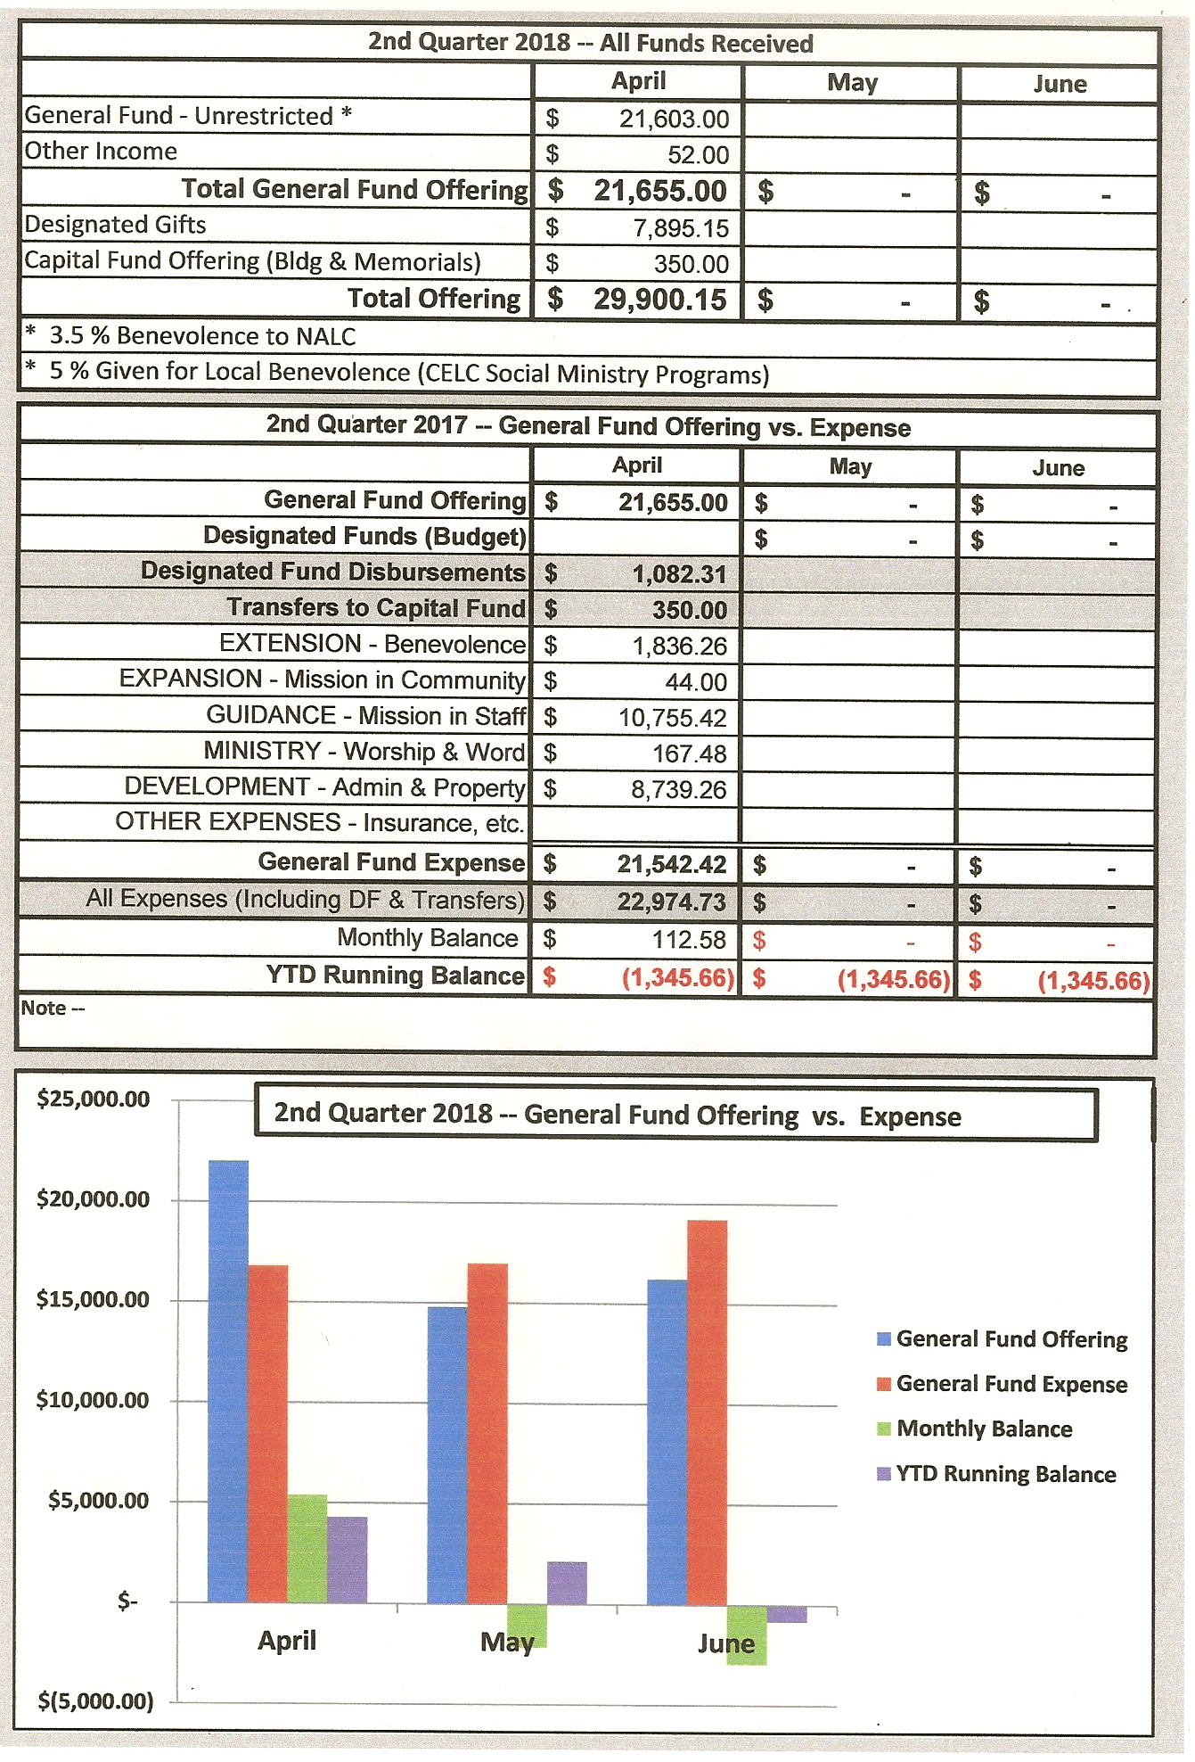

May 2018

|  |  |  |  |  |  |  |
| --- | --- | --- | --- | --- | --- | --- |
| Sunday | Mon | Tuesday | Wed | Thursday | Fri. | Sat. |
|  |  | 1 | 2 | 3 | 4 | 5 |
| 6  Sunday School 9:30am  The Divine Service  10:30am  Congregational Meeting immediately following worship | 7 | 8  Women’s Bible Study  10am | 9  Bible Study  5:30am  Choir Practice  7:00pm | 10  Food Pantry  11am-12:30pm  Service of Confession & Absolution 12:30-1:30pm | 11 | 12 |
| 13  Sunday School 9:30am  The Divine Service  10:30am | 14 | 15 | 16  Bible Study  5:30am  Choir Practice  7:00pm | 17  Food Pantry  11am-12:30pm  Service of Confession & Absolution 12:30-1:30pm | 18 | 19 |
| 20  Sunday School 9:30am  The Divine Service  10:30am | 21 | 22 | 23  Bible Study  5:30am  Choir Practice  7:00pm | 24  Food Pantry  11am-12:30pm  Service of Confession & Absolution 12:30-1:30pm | 25 | 26 |
| 27  Sunday School 9:30am  The Divine Service  10:30am  Prime Timer’s Outing leave the church 12:15pm for Pizza & Fun!! | 28  Office  Closed  Memorial Day | 29 | 30  Bible Study  5:30am  Choir Practice  7:00pm | 31  Food Pantry  11am-12:30pm  Service of Confession & Absolution 12:30-1:30pm |  |  |

**Website**

**If you have the chance, please go into www.celcstanley, and look at our new website. We are still adding things but it is up and running.**

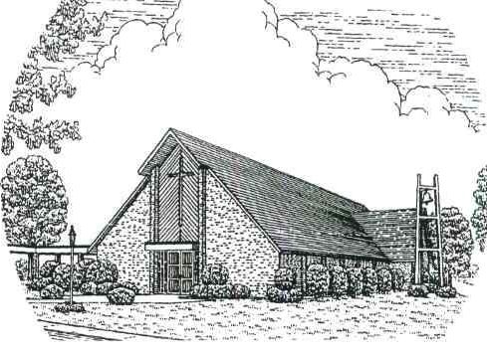

**Christ’s Evangelical Lutheran Church**

203 S. Main St. Stanley, NC 28164

CELC

Newsletter

May 2018



**Schedule:**

**Sunday**

9:30am Sunday School

10:30am Worship Service

**Wednesday**

5:30pm Bible Study

7:00pm Choir Practice

**Church Office Hours:**

Monday—Friday 8:30am until 1:00pm

Pastor: Rev. Wesley R. Frye, STS

Administrative Assistant: Julie Bodenheimer

Facilities: Rick Chapman